**PART I: SQL with Amazon RDS and Redshift [100 points]**

Let’s assume you’re the seller for your e-commerce website, now designing the SQL tables for your products, customers, and orders, to keep track of the basic sales condition.

Refer to textbook page 244~255 for MySQL, page 269~279 for Amazon Redshift.

1) SQL schema design: draw ER diagram like p244 Figure 6.1 for 3 tables: [10 points]

customer : order = 1 : N

order : product = N : M

Customers (cid, customer_name, gender, phone)

Order (oid, cid, is_completed, total_price)

OrderHasProduct (oid, pid, product_count)

Product (pid, product_name, price, cost, is_on_sale, available_stock, description)

Types: gender boolean, is_completed boolean, total_price int, product_count int, price int, cost int, is_on_sale boolean, available_stock int. all others are string

(if you have your own thought about the schemas, please post on Piazza or discuss with TA ahead.)

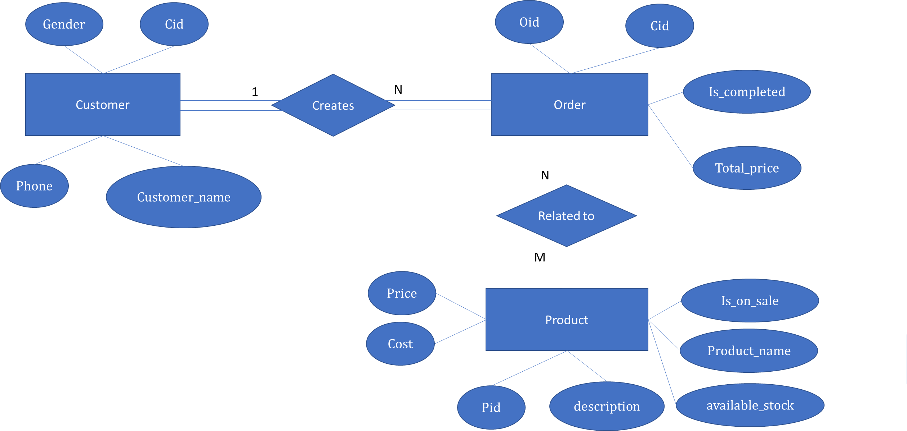

2) Locally: create the above tables in your local SQL or MySQL server. [30 points]

Create tables

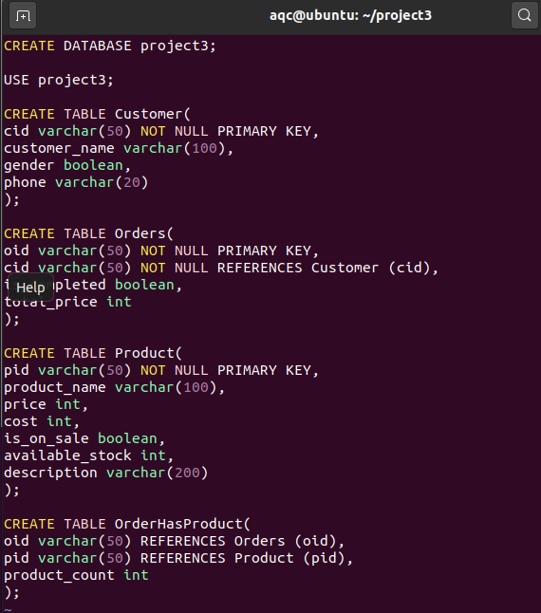

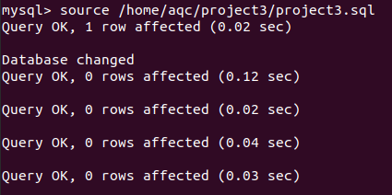

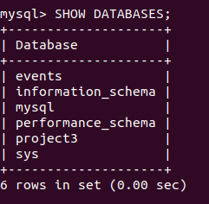

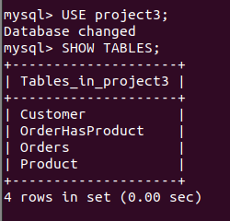

Insert 8 lines of data for each table and do the following queries.

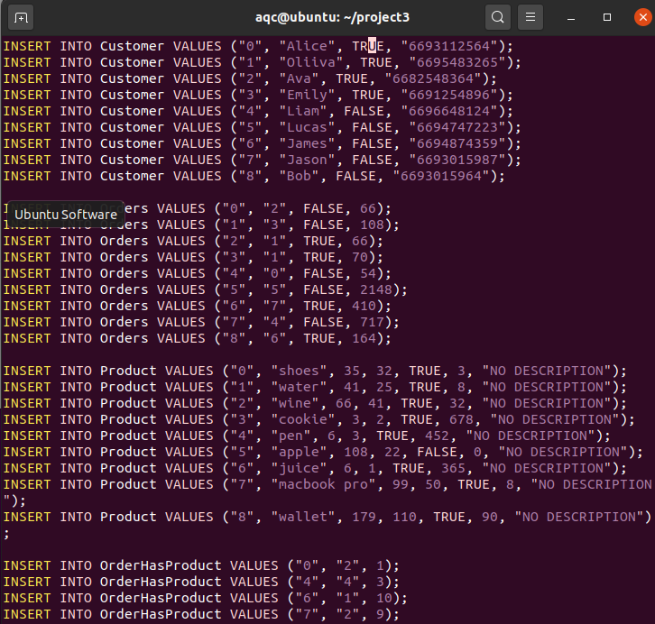

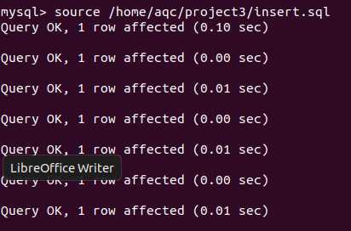

consider generating some data that can print out at least 2 lines of results when doing the queries.

1) Get all the order.

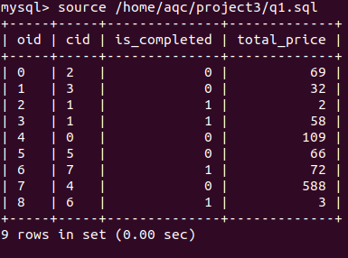

2) Get top 3 orders with highest total_price.

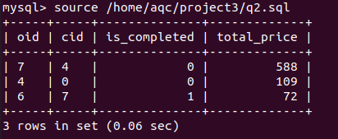

3) Get all the orders belong to customer Bob.

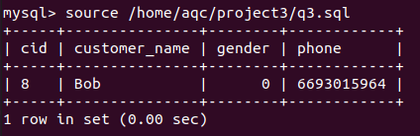

4) Get the number of products that is on sale.

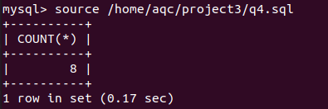

5) Get the total income for the completed orders. (income = price – cost)

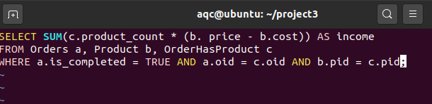

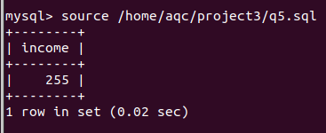

6) Get the product and the number that need to purchase to fulfill the order. (Available_stock - product_count)

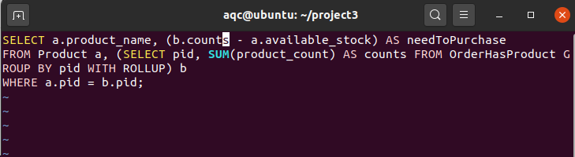

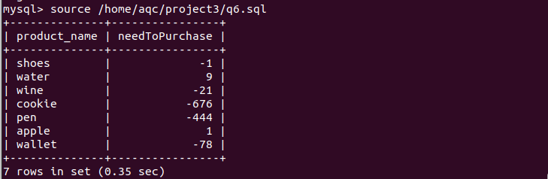

3) Amazon RDS: refer to Box 6.4 6.5 in p253 to launch an RDS instance, and create the above MySQL tables, execute the data insertion and doing queries 4~6. You can reuse the code in part 2. [30 points]

*Create RDS instance and launch instance*

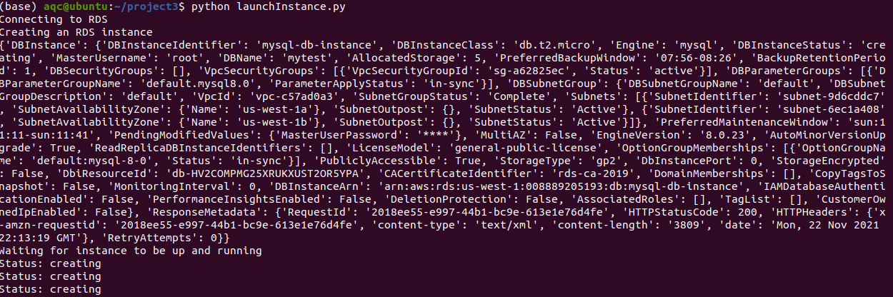

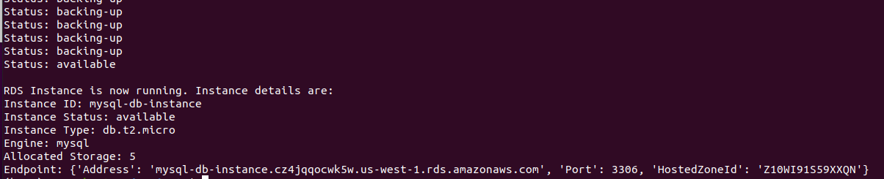

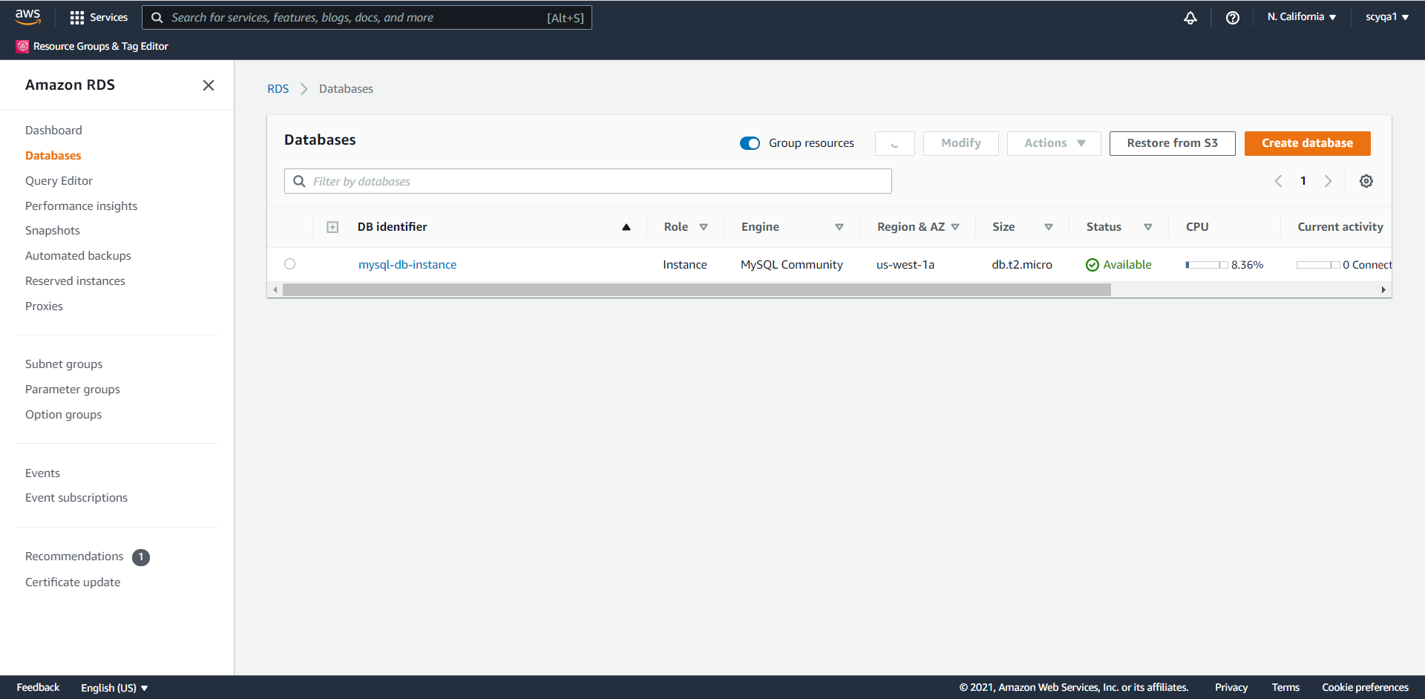

Create a MySQL table, writing and reading from the table

For this part, some libraries didn’t work on my Linux VM after many attempts, so that I decide to run it on my Window laptop.

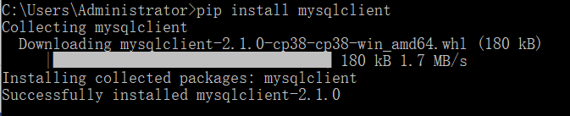

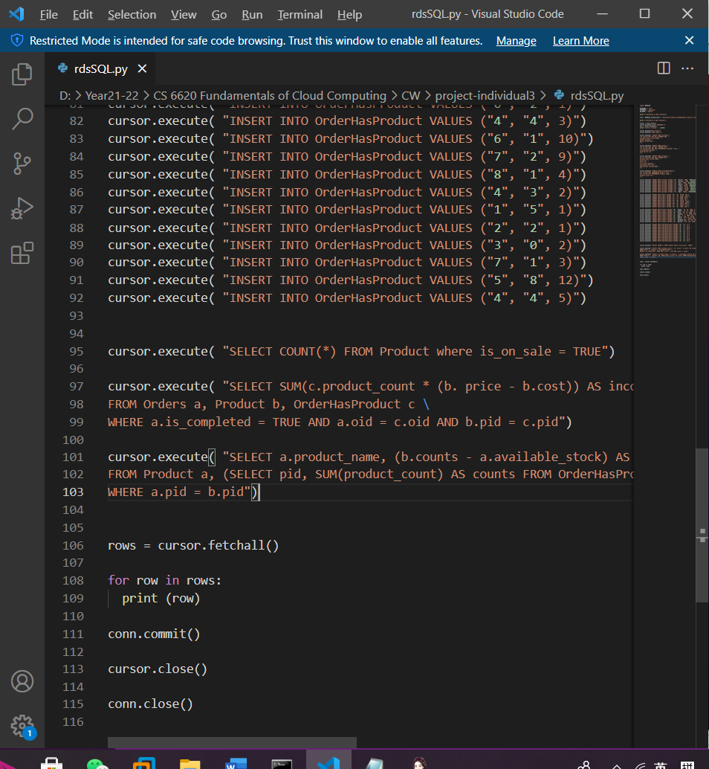

Query 4



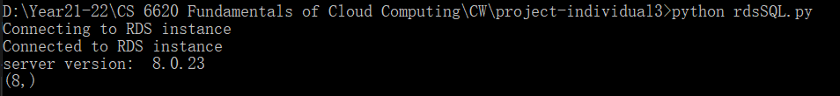

Query 5

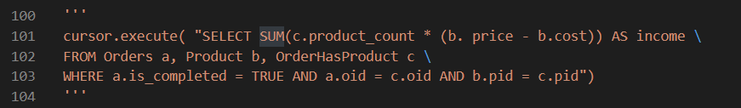

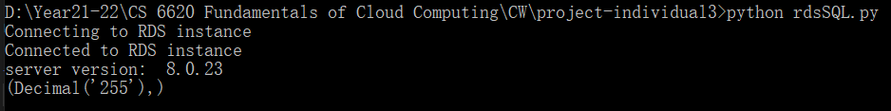

Query 6

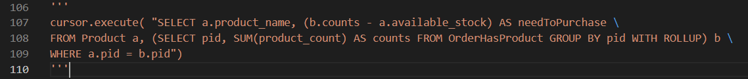

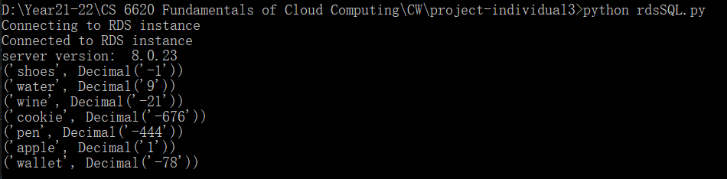

4) Amazon Redshift: refer to Box 6.13 to load your data into with S3 bucket. You can use any input type other than csv. Show the process to add additional nodes into the cluster, remove nodes from the cluster while remaining operational. The nodes can be duplicated data but different names. Do queries 1~3. [30 points]

Create a Redshift cluster

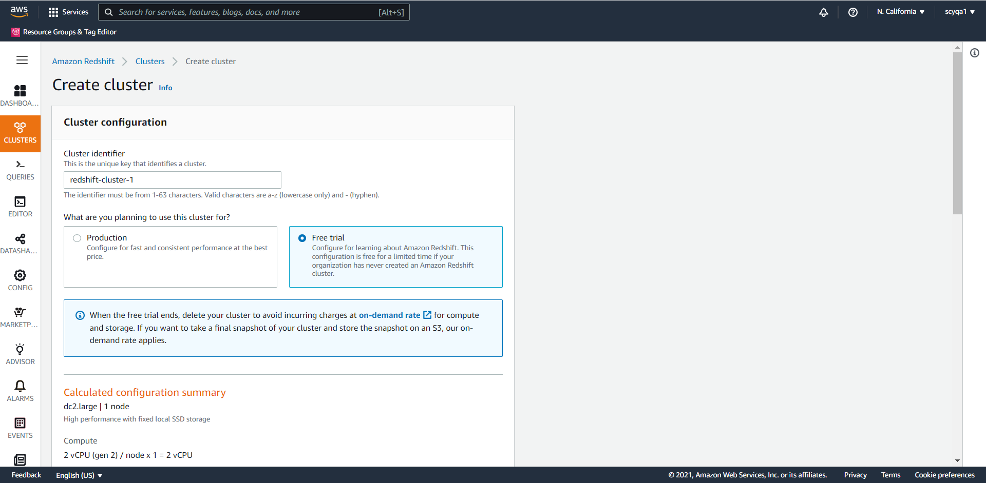

Specify the node type and cluster type

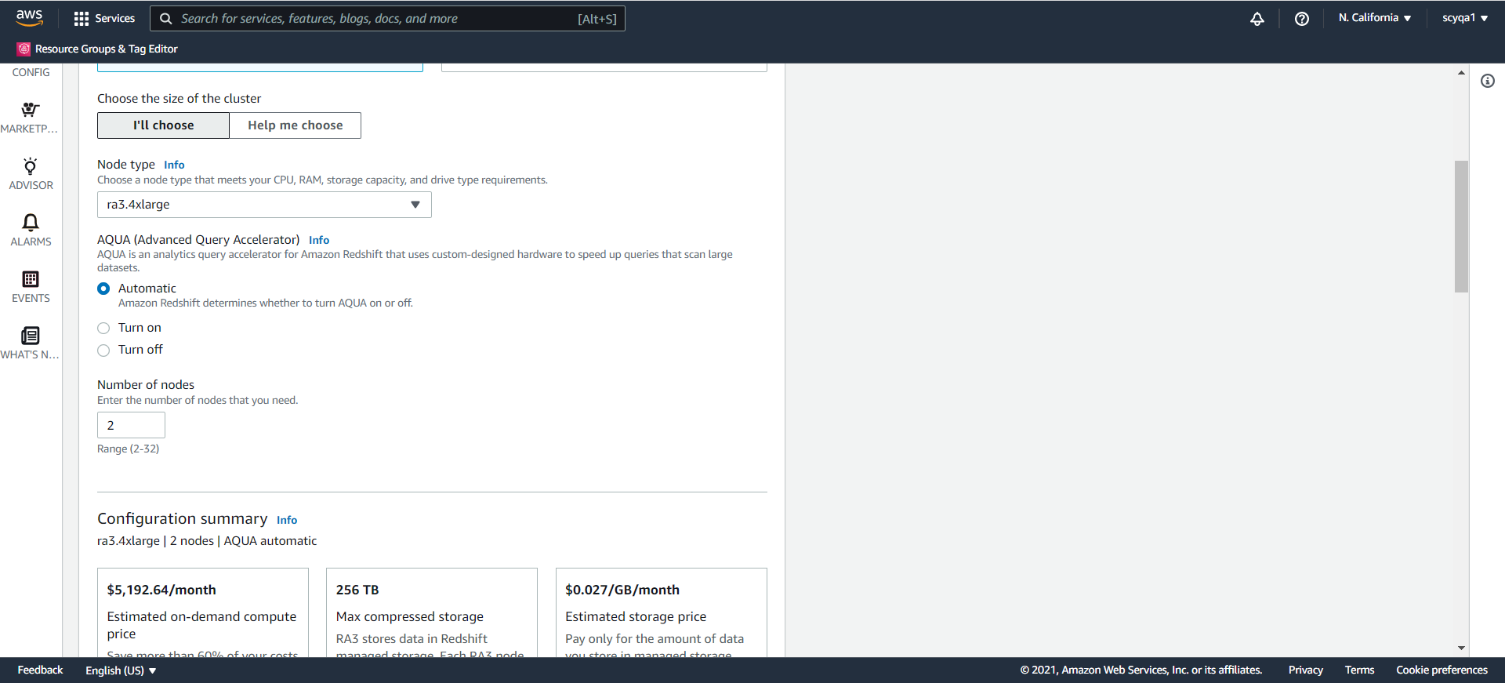

Other configurations

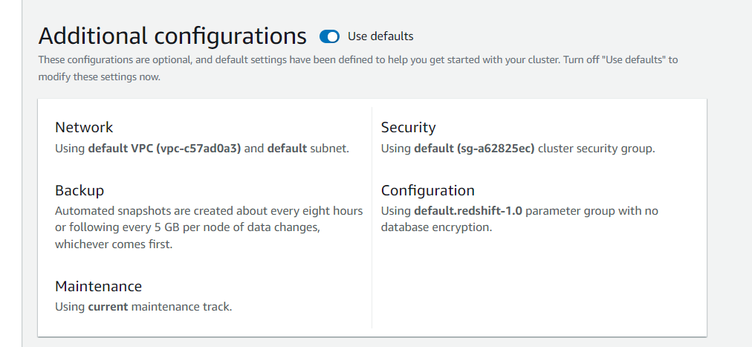

Results

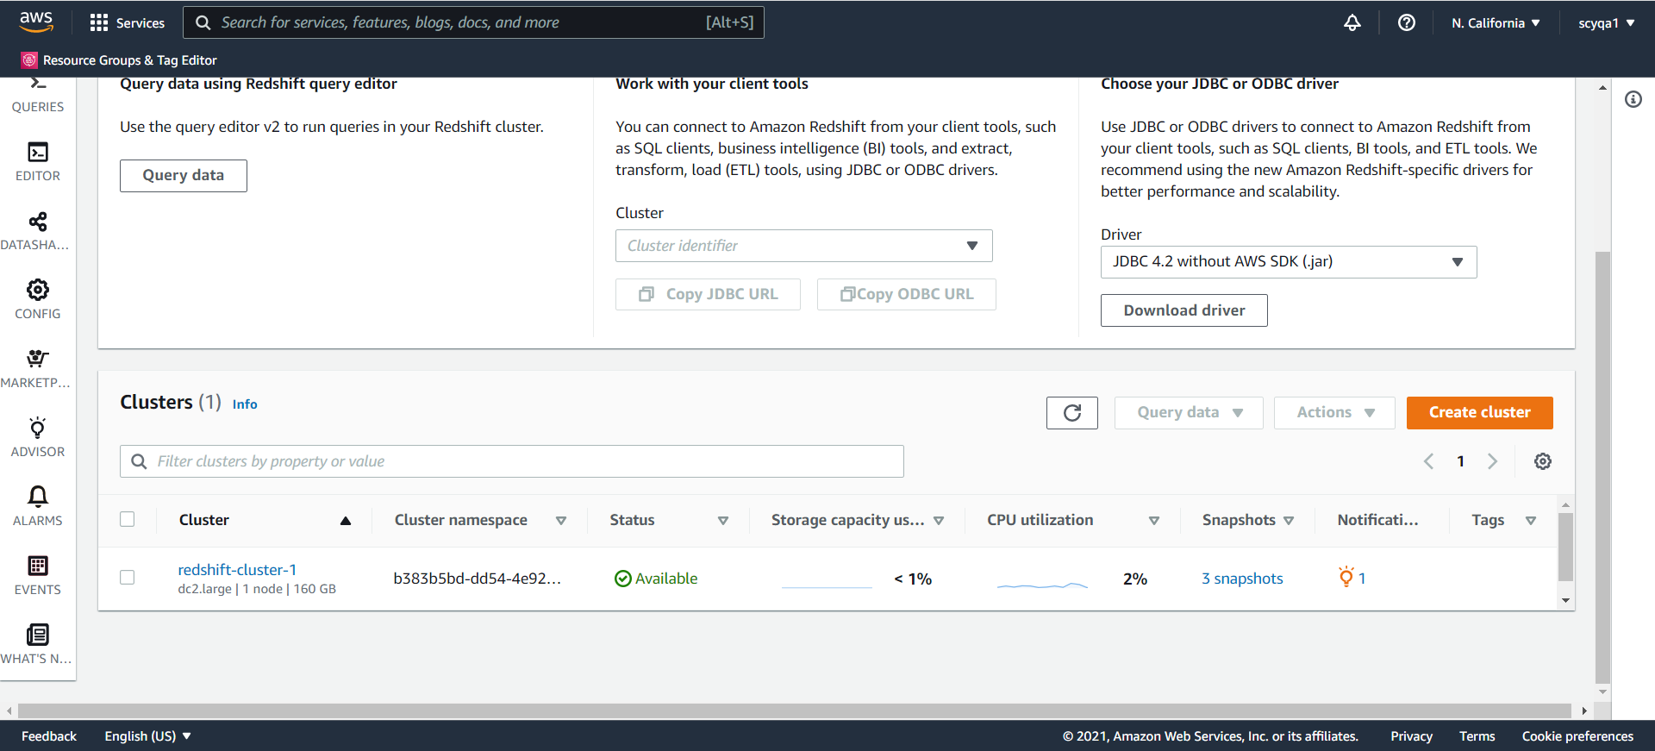

Connect to a database

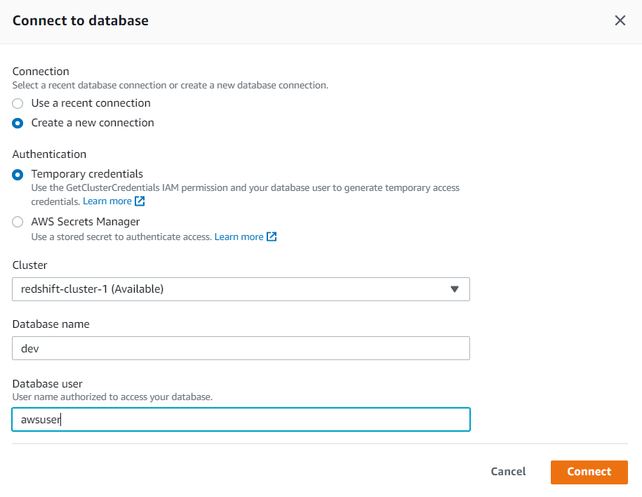

Create Table

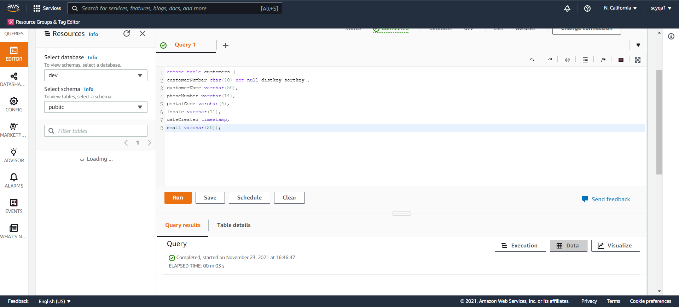

Upload JSON data to S3

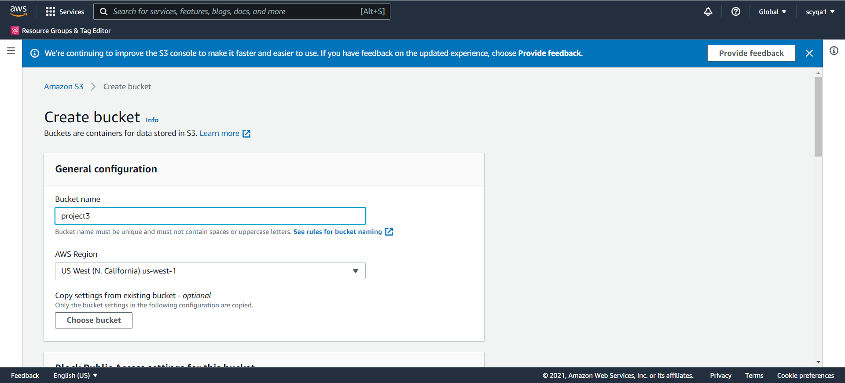

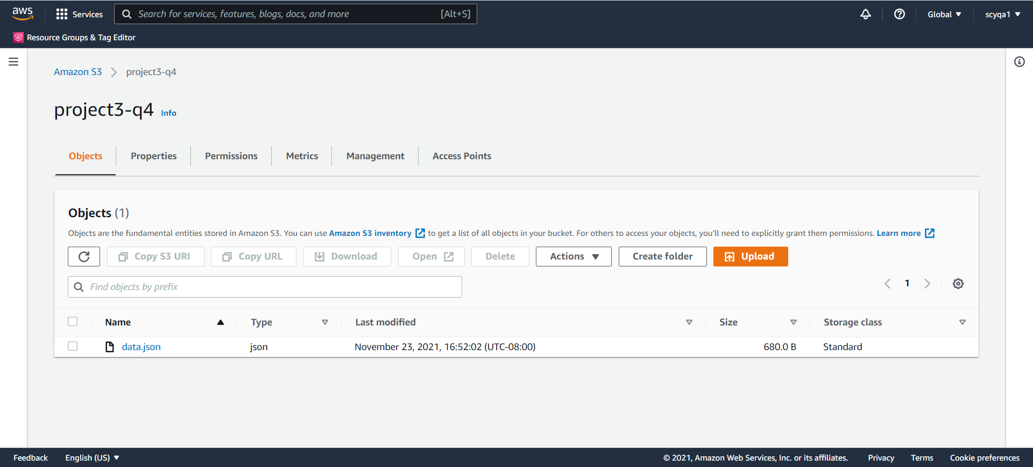

Resize

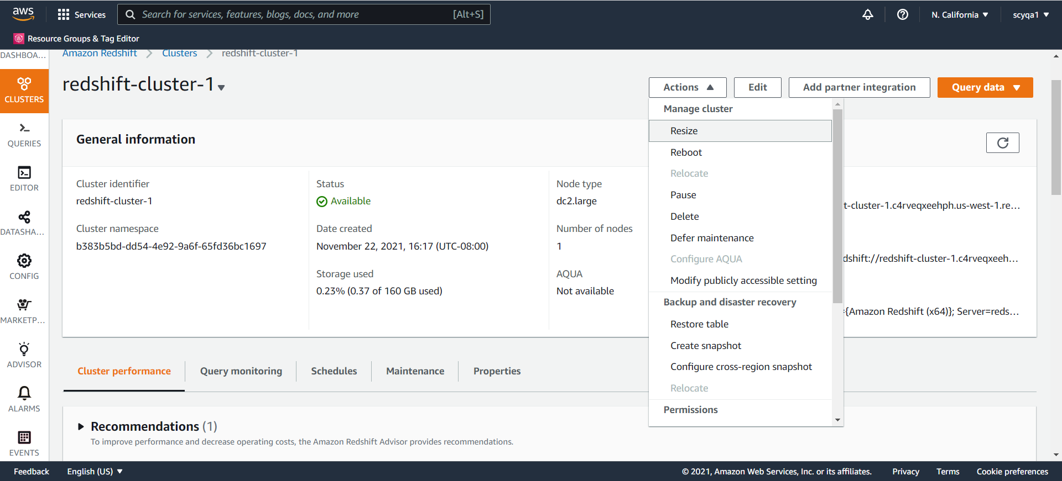

Add nodes

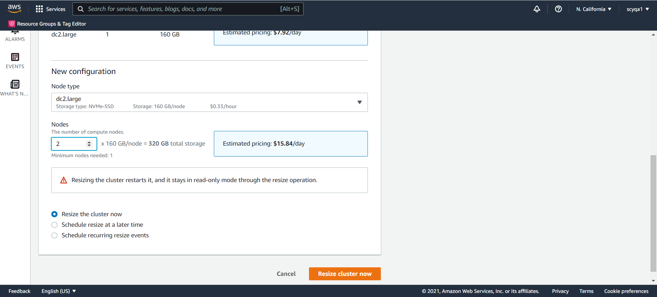

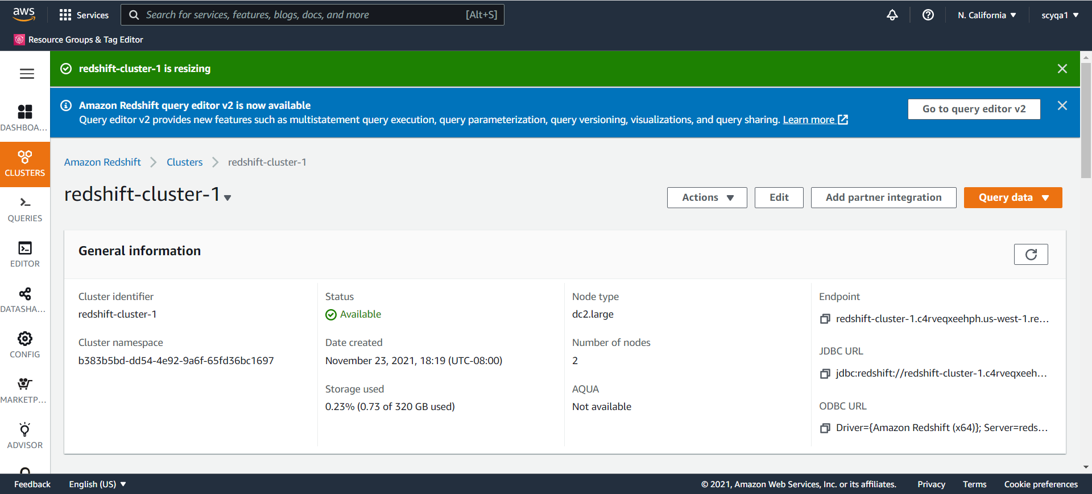

Similarly, remove nodes by resize

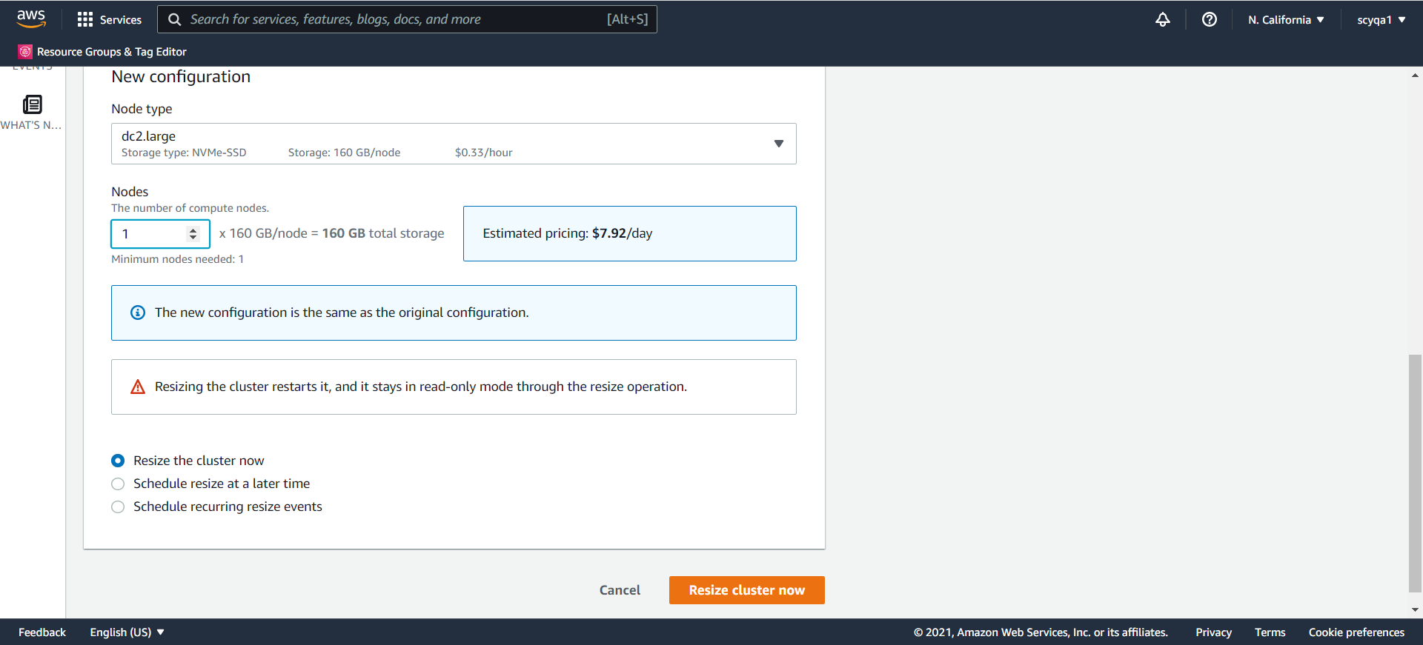

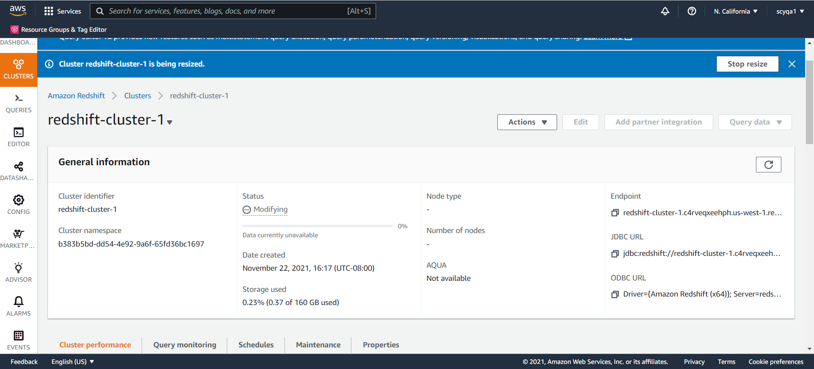

Copy S3 data into Redshift

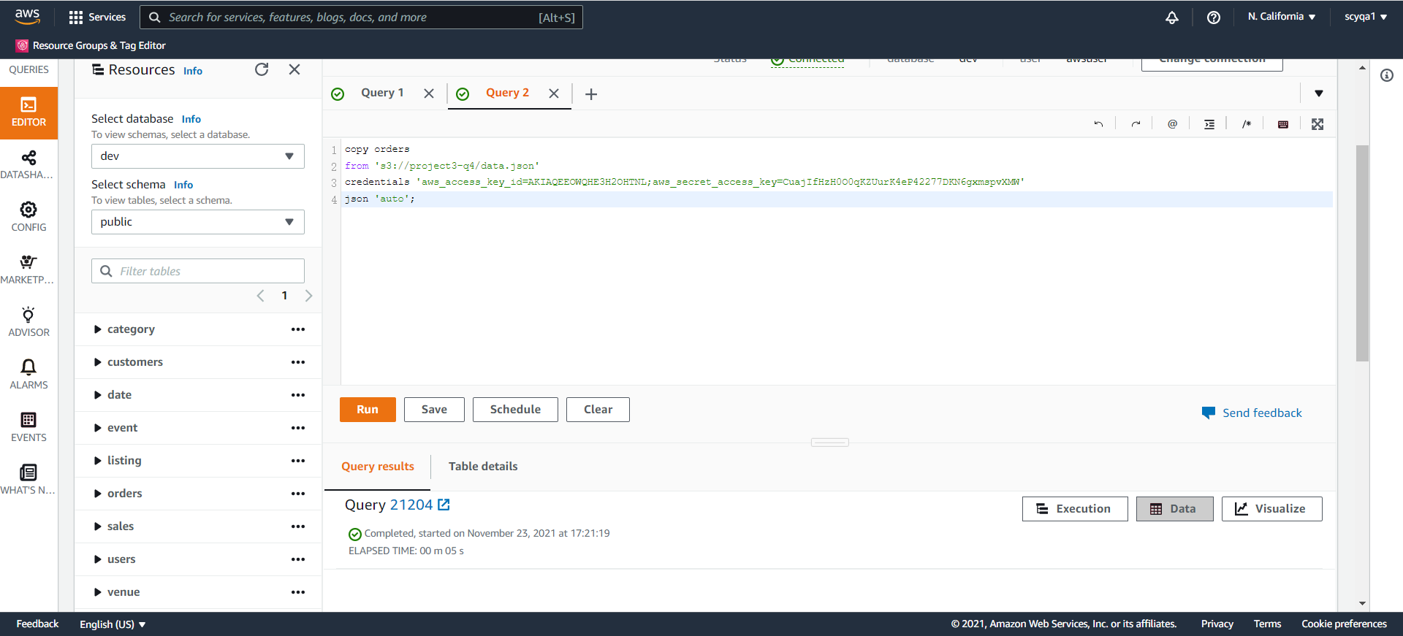

Do queries

Query 1

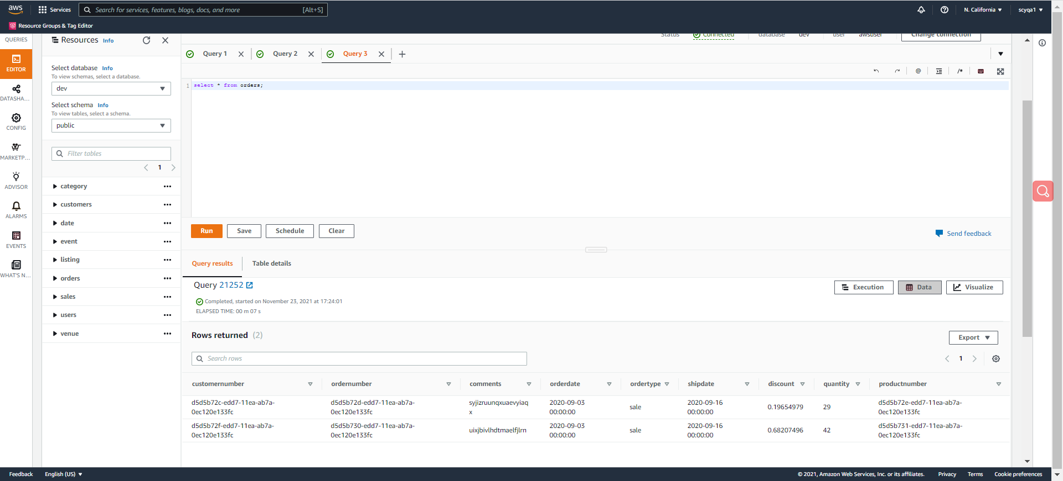

Query 2

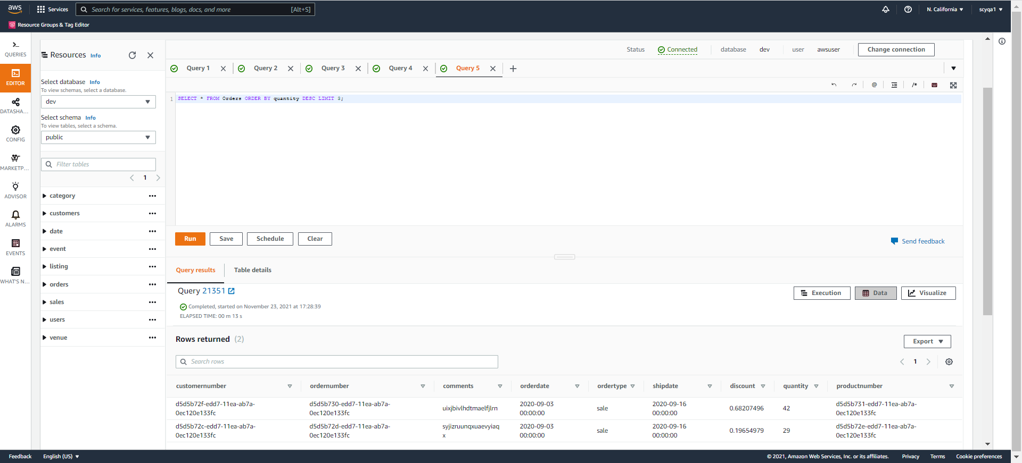

Query 3

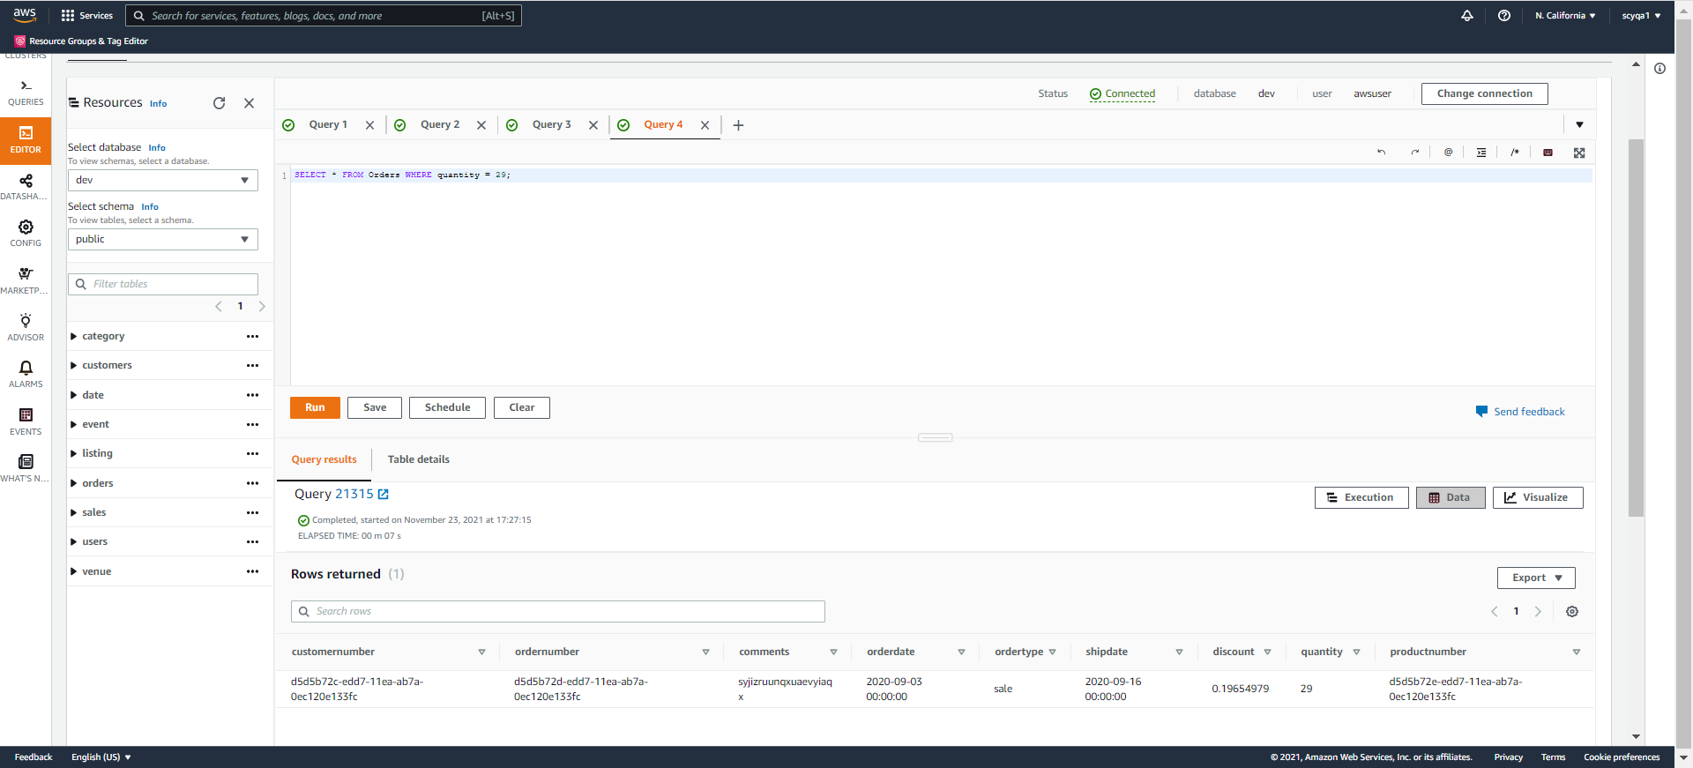

**PART II: Build a basic Web App and on AWS [100 points][Coding is required]**

Please study this example of building a complete Web App on AWS, using the below infrastructure (IaaS):

https://medium.com/the-andela-way/designing-a-three-tier-architecture-in-aws-e5c24671f124

Step 1: Create your IaaS for the Web App: For the IaaS (infrastructure) part, replicate all the steps shown above to create the VMs you need.

Create VPC

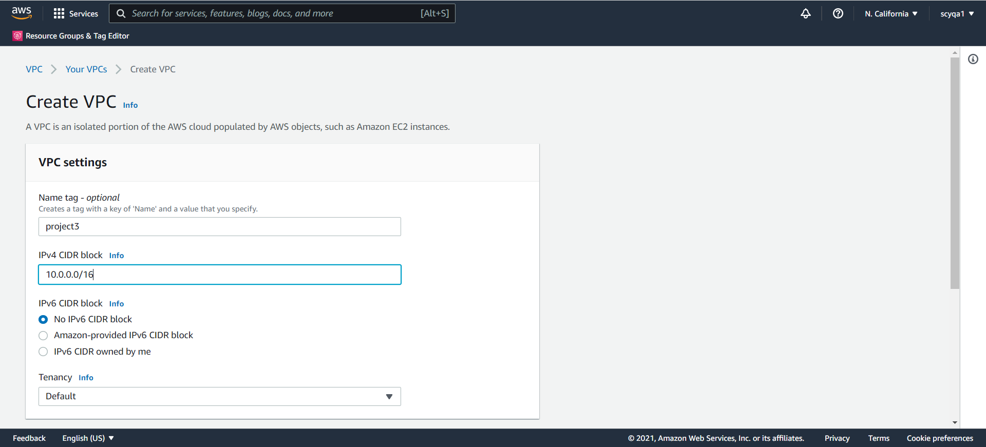

Setup the Internet Gateway

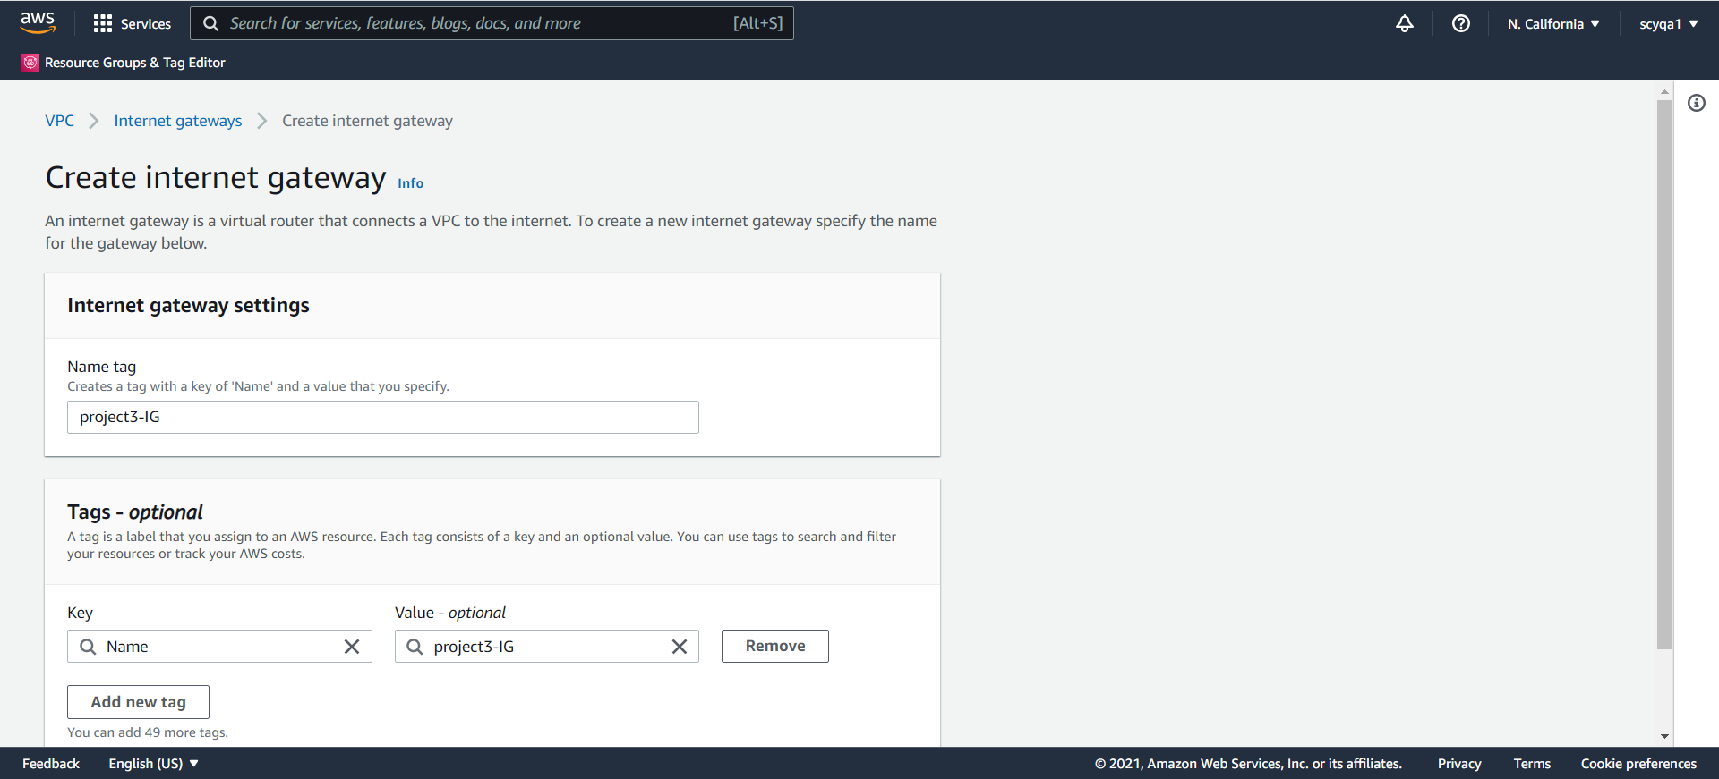

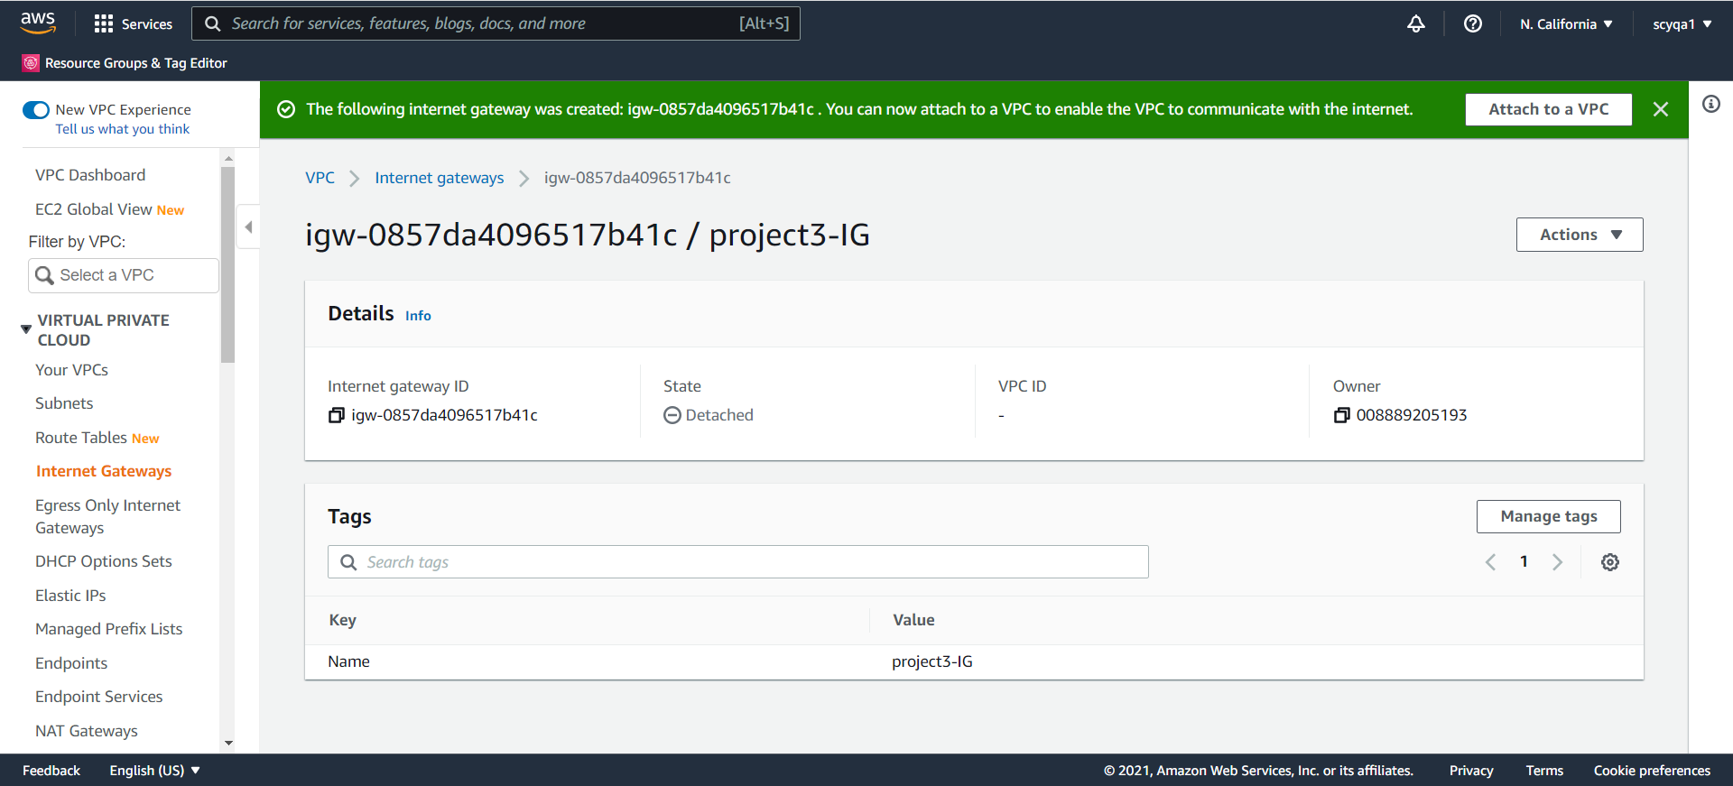

Attach the VPC to the internet gateway

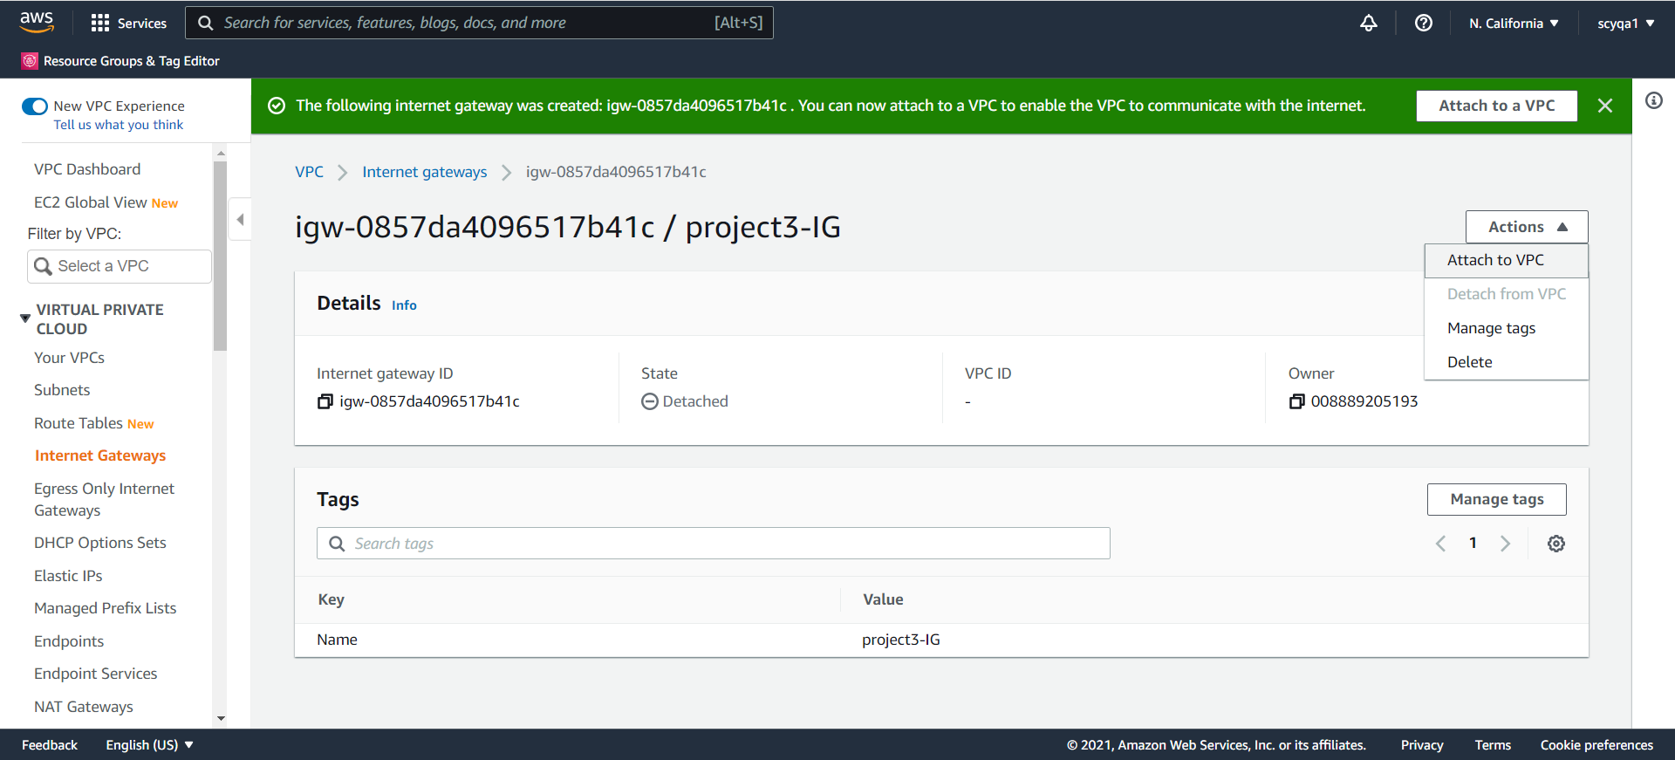

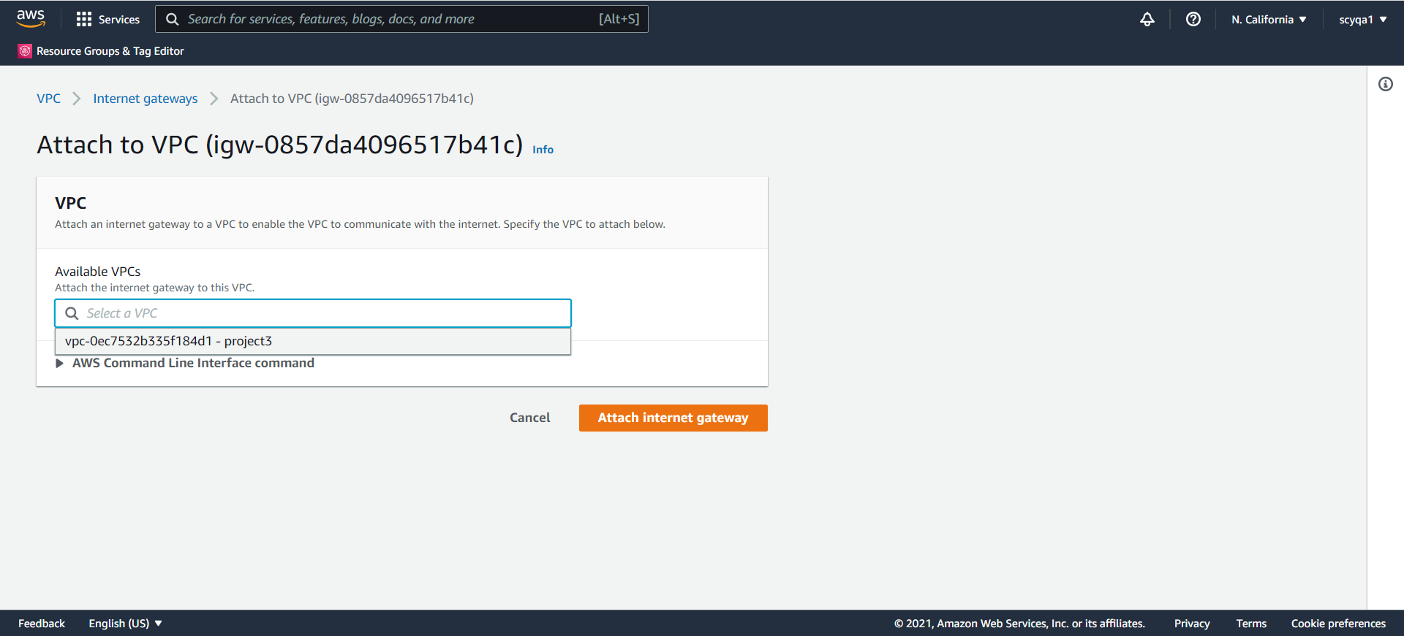

Create 4 Subnets

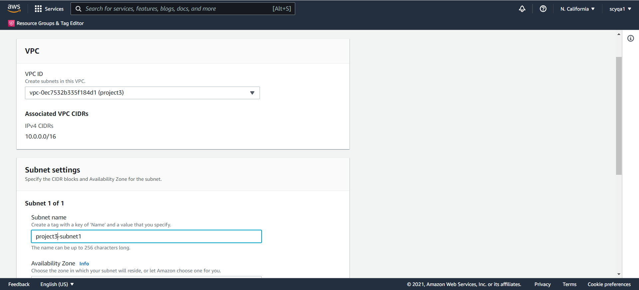

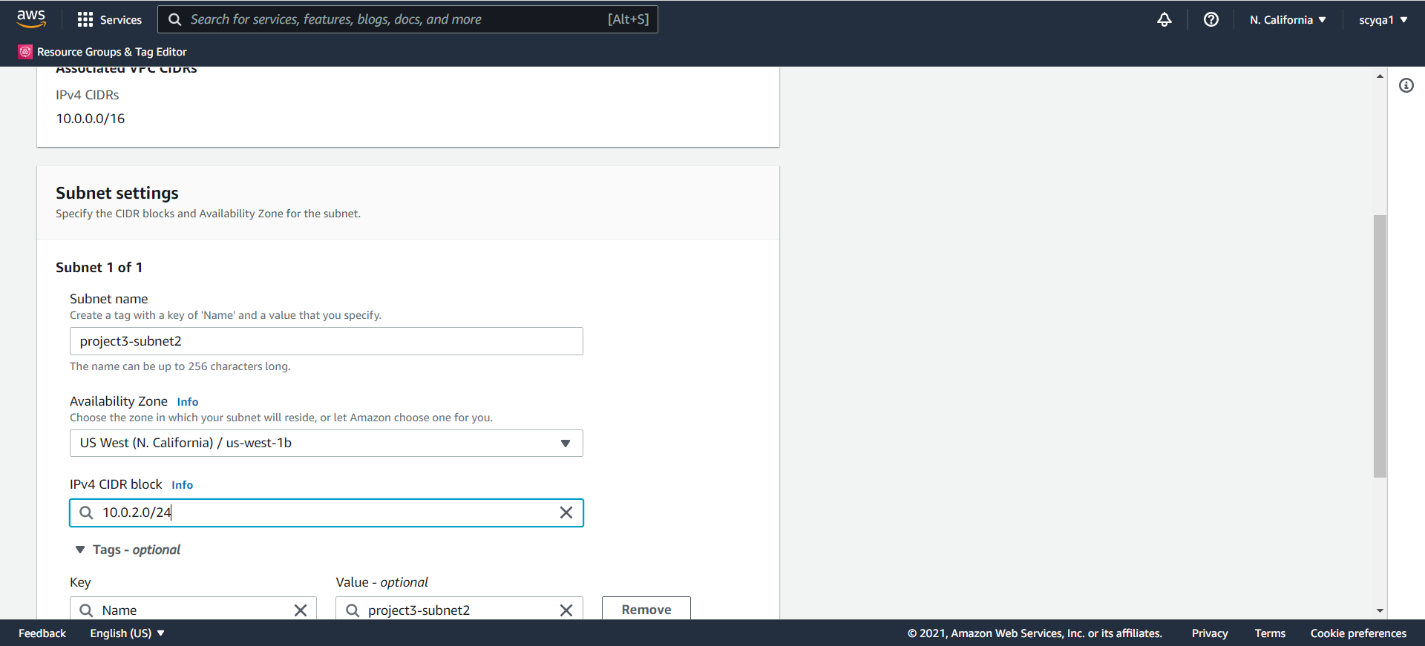

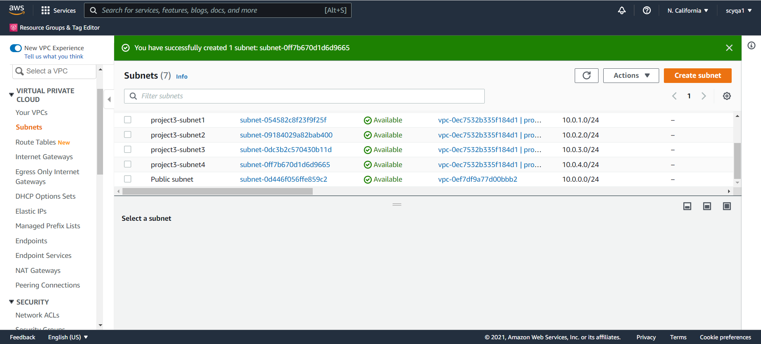

Create Two Route Tables

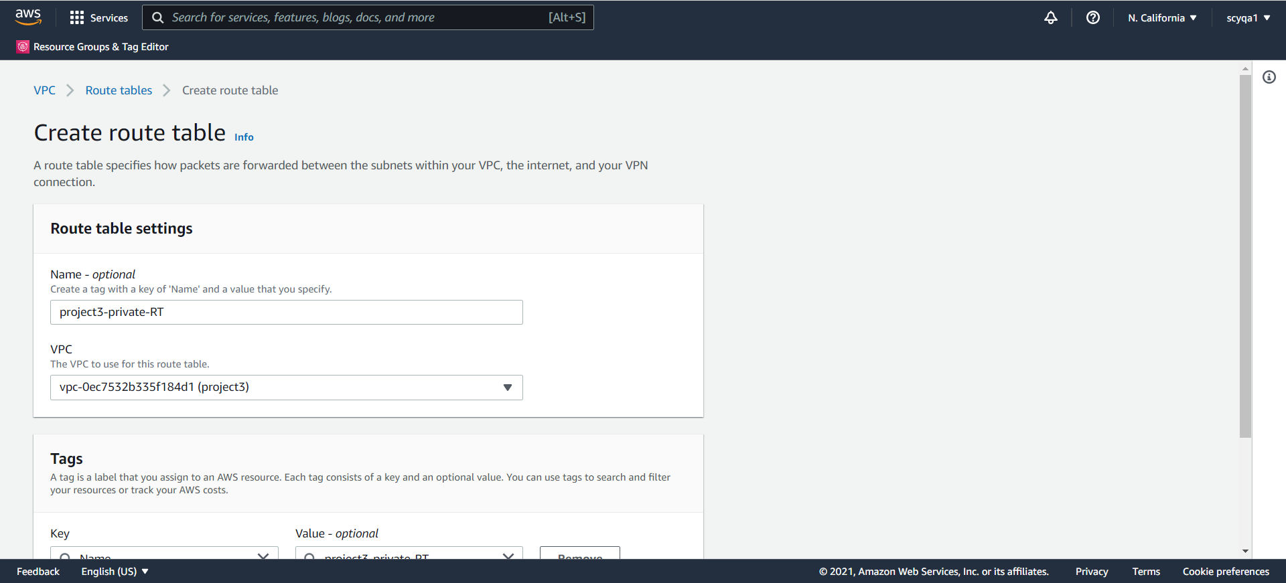

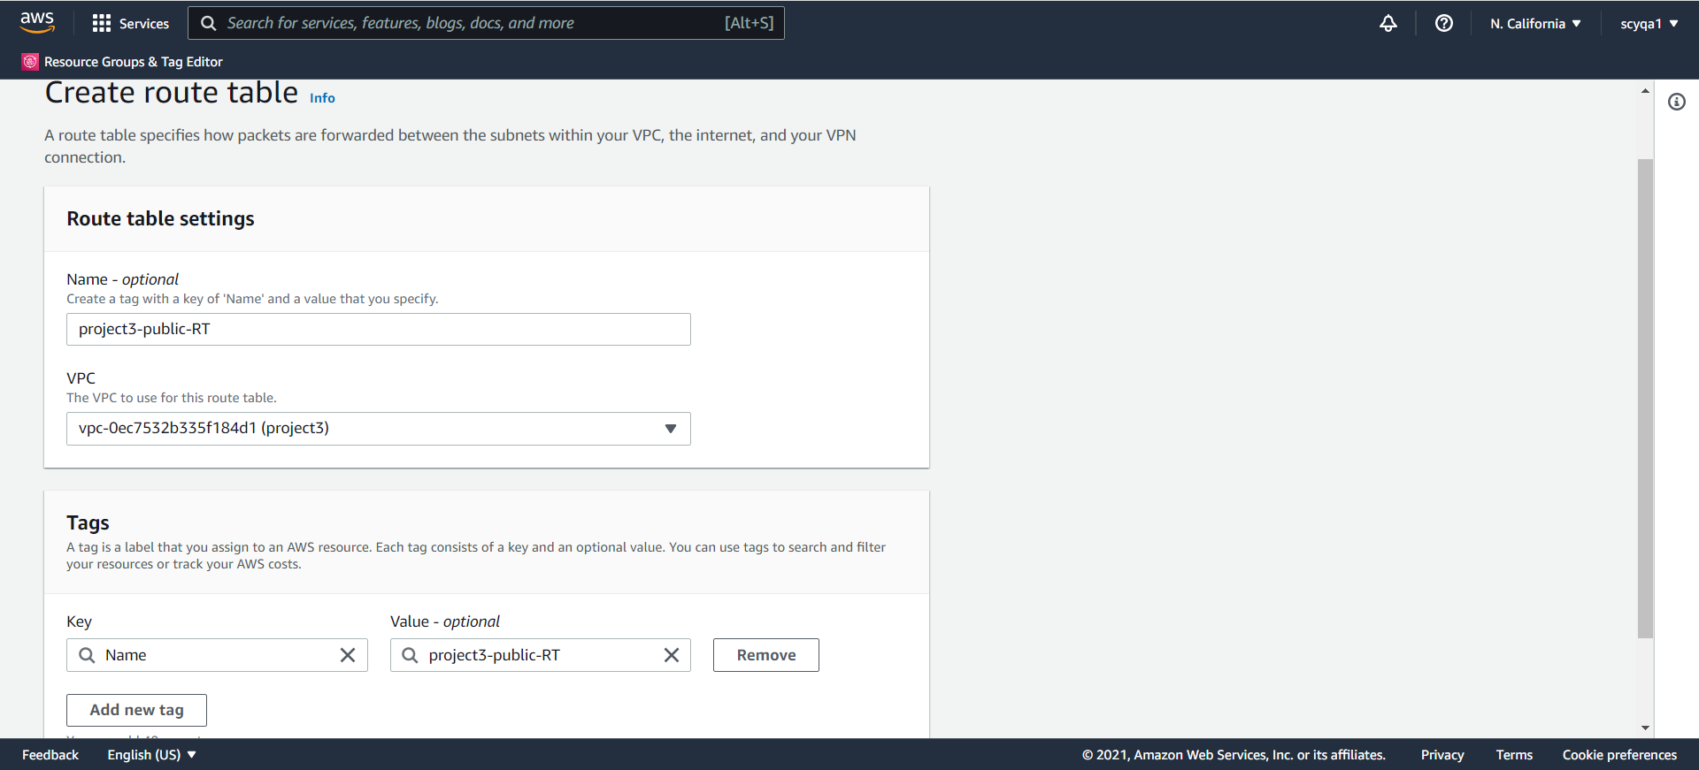

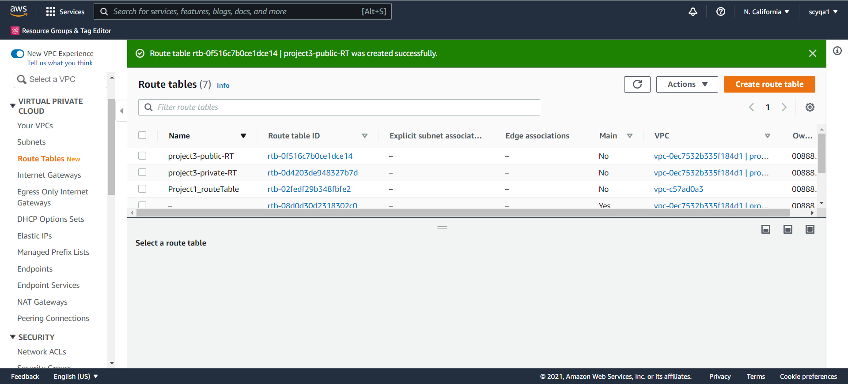

Subnet Association

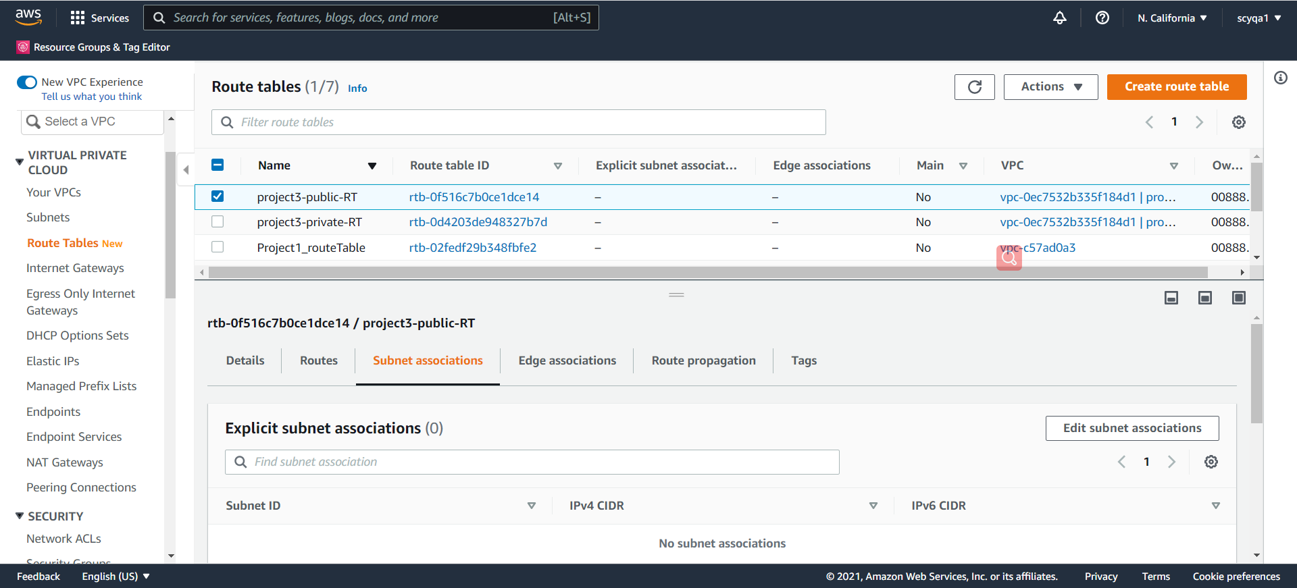

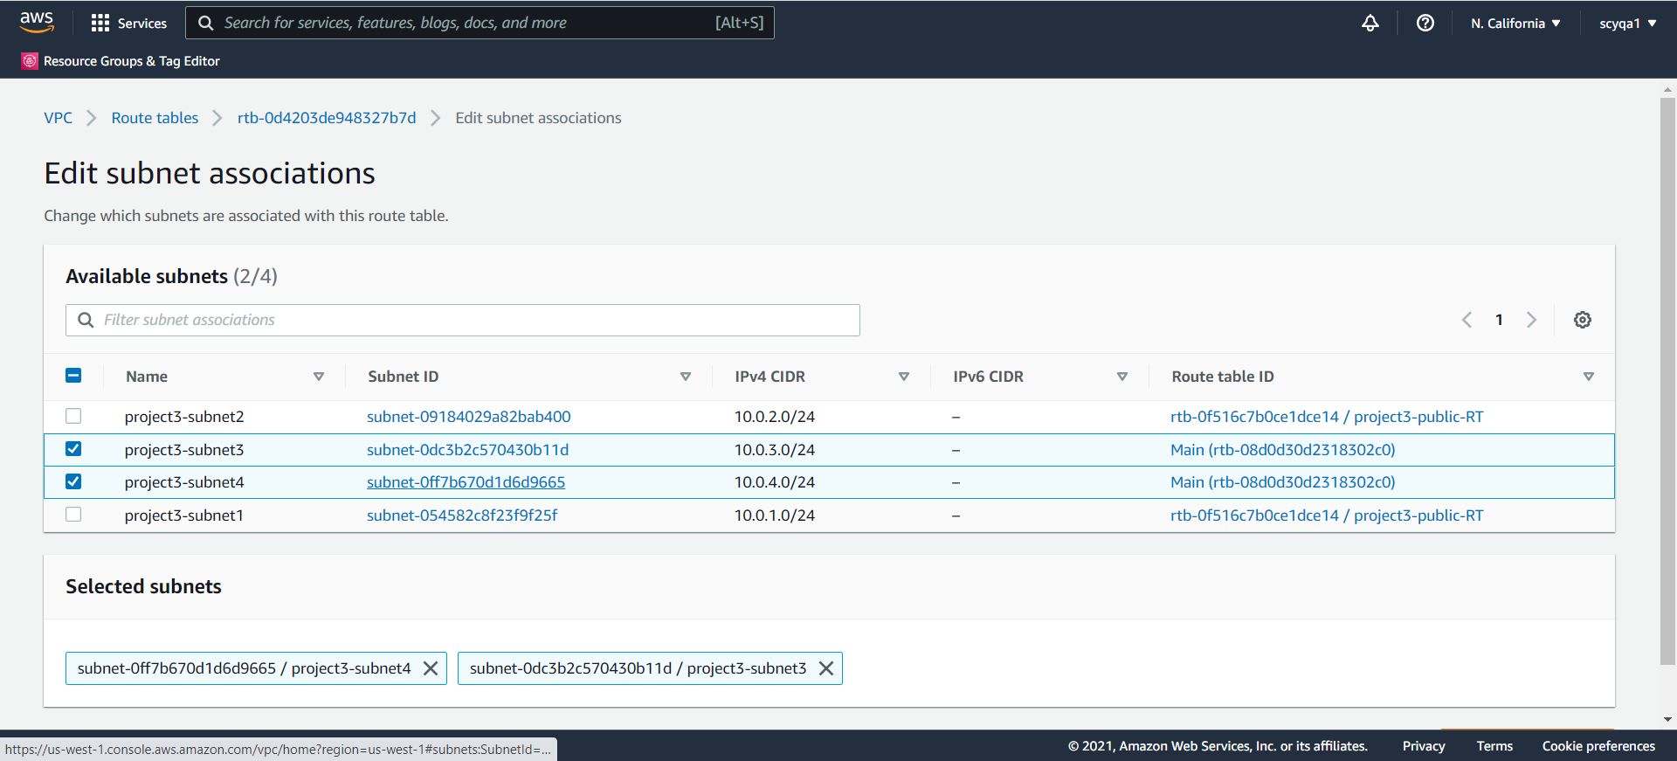

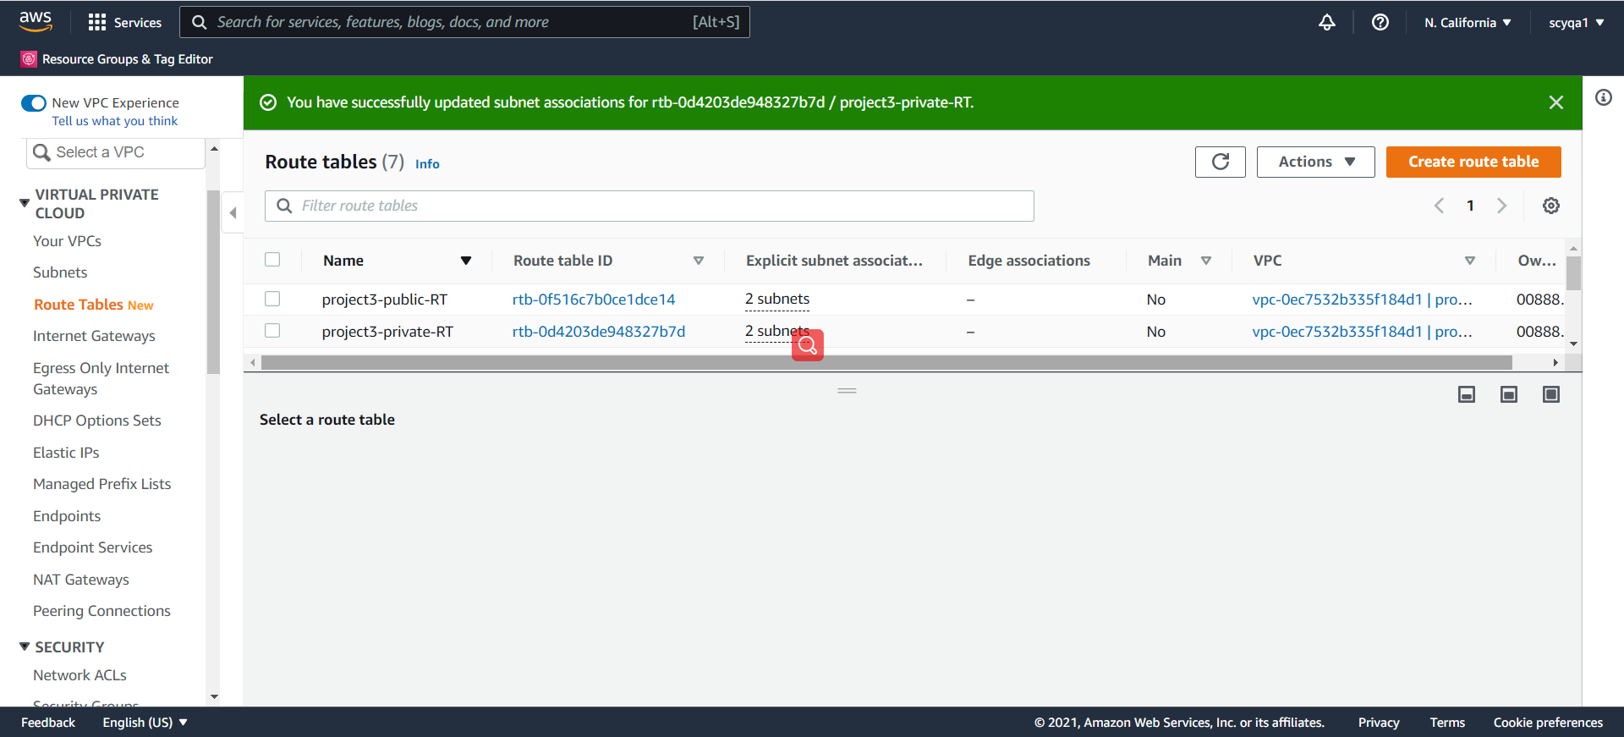

Route the traffic to the internet through the internet gateway

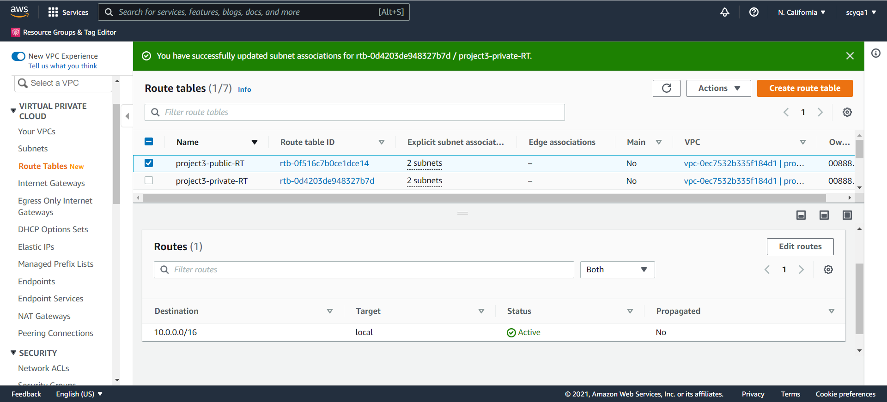

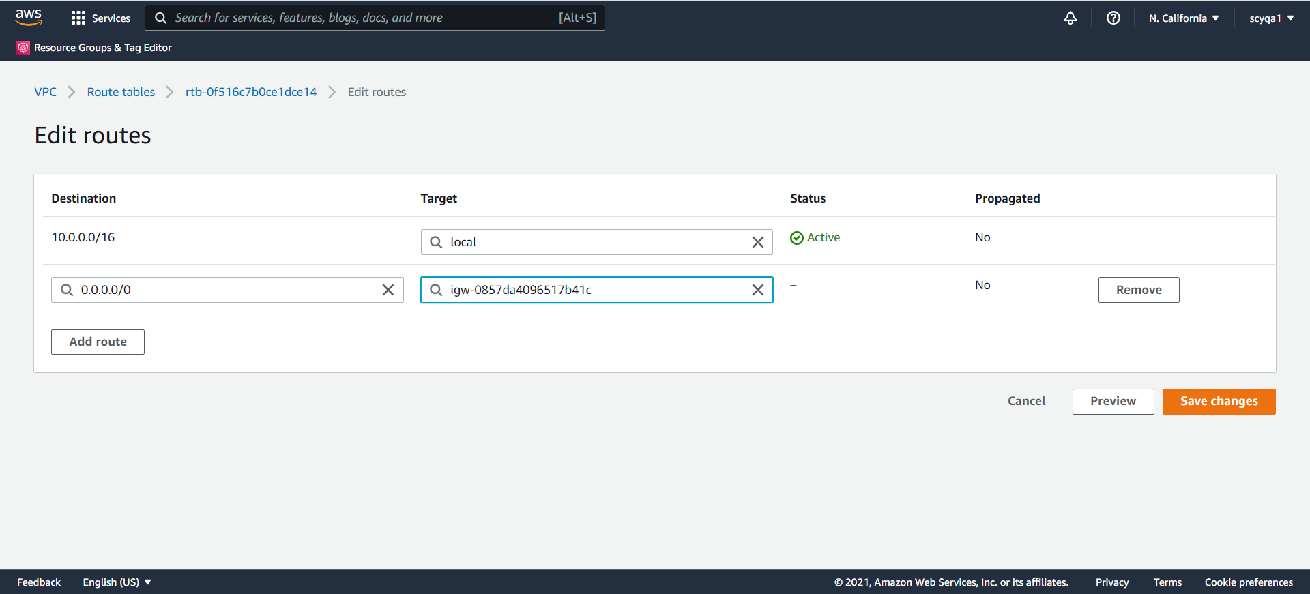

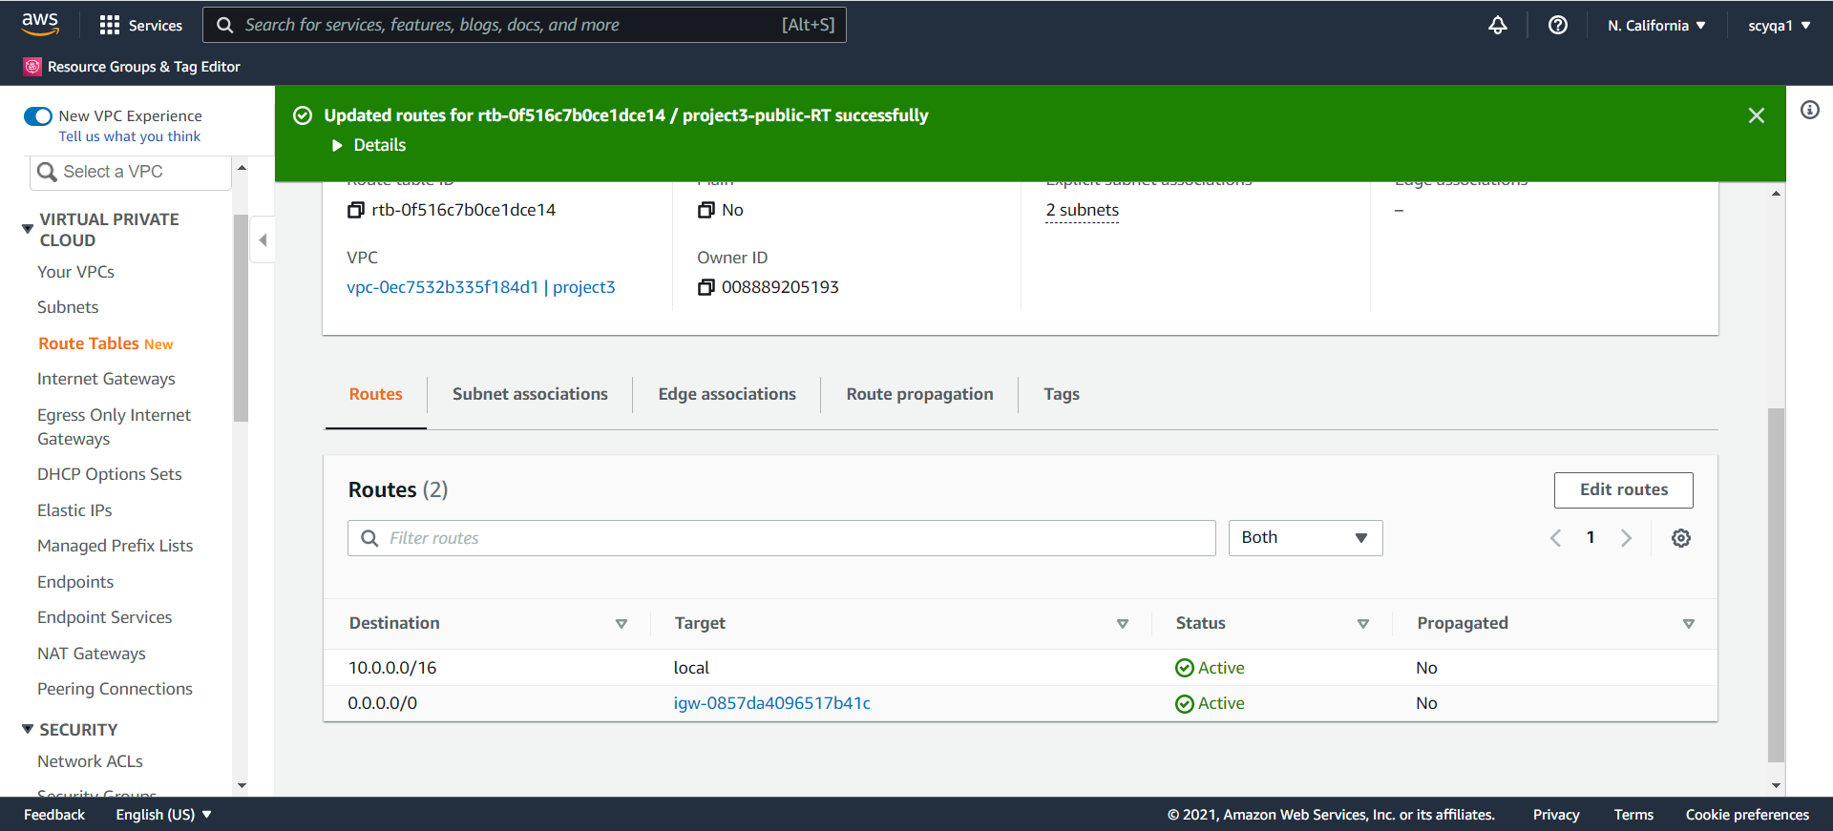

Create the NAT Gateway

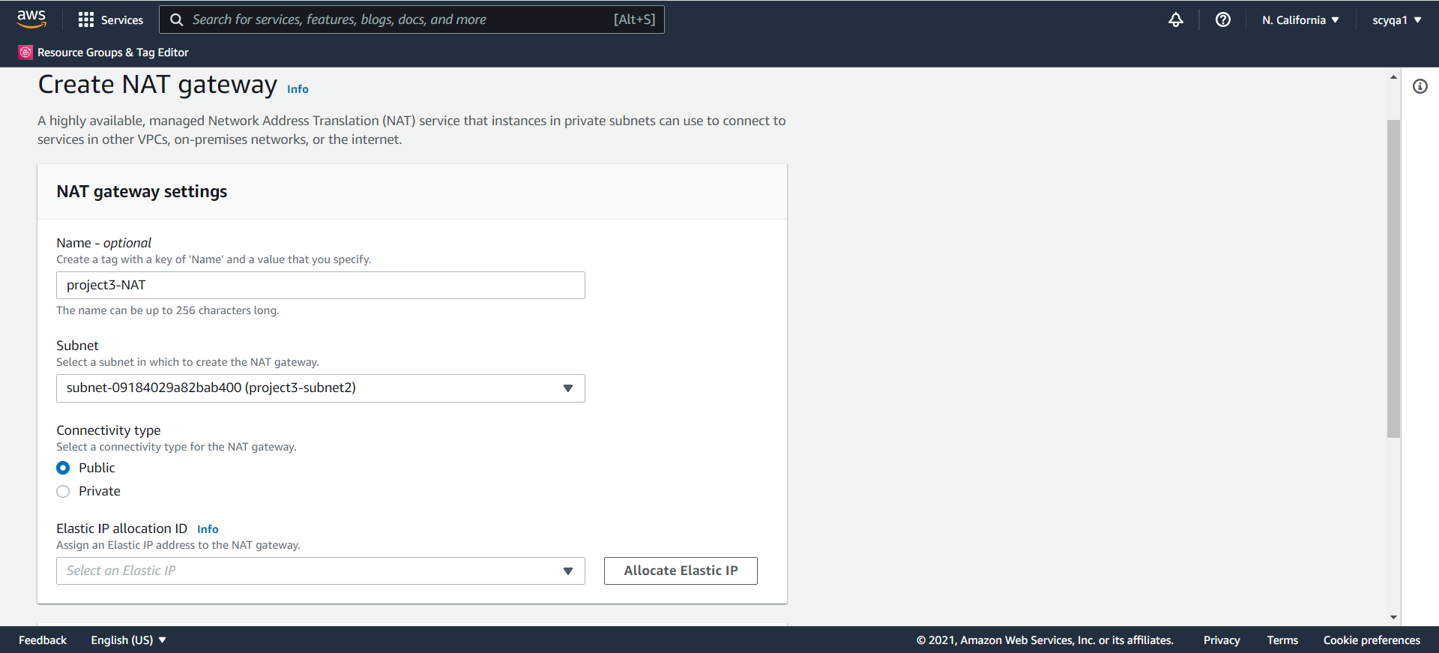

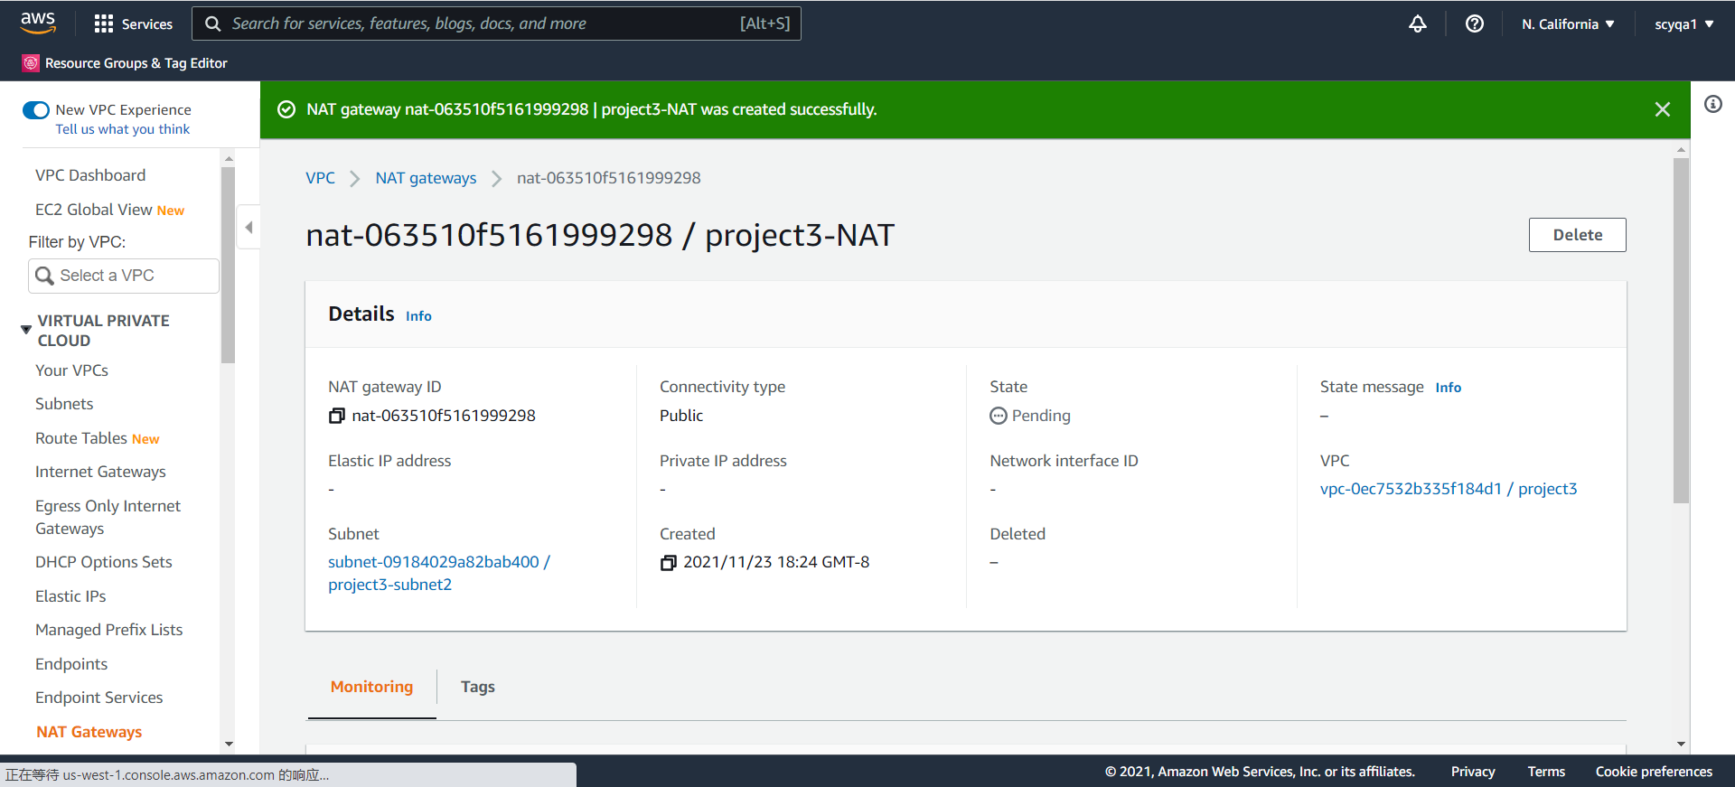

Edit the private route table to make use of the NAT gateway to access the internet

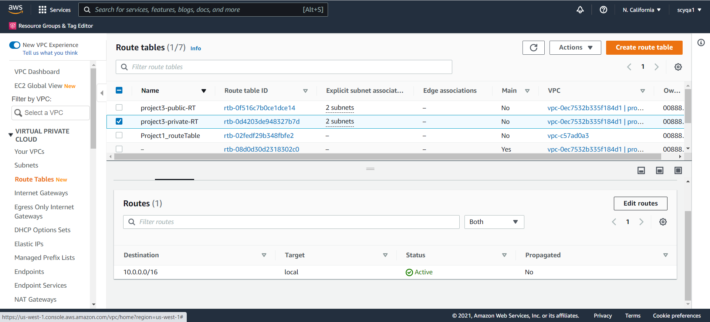

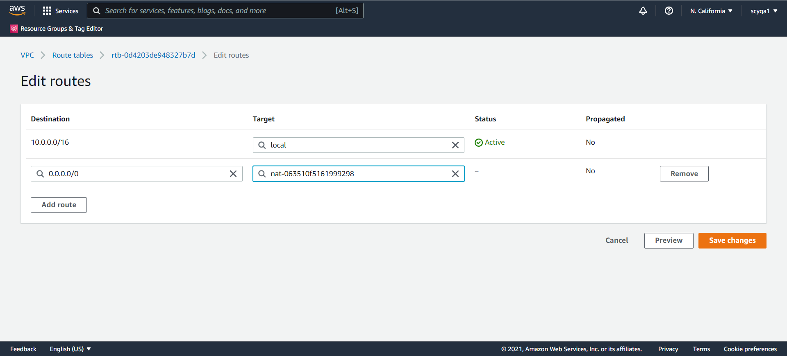

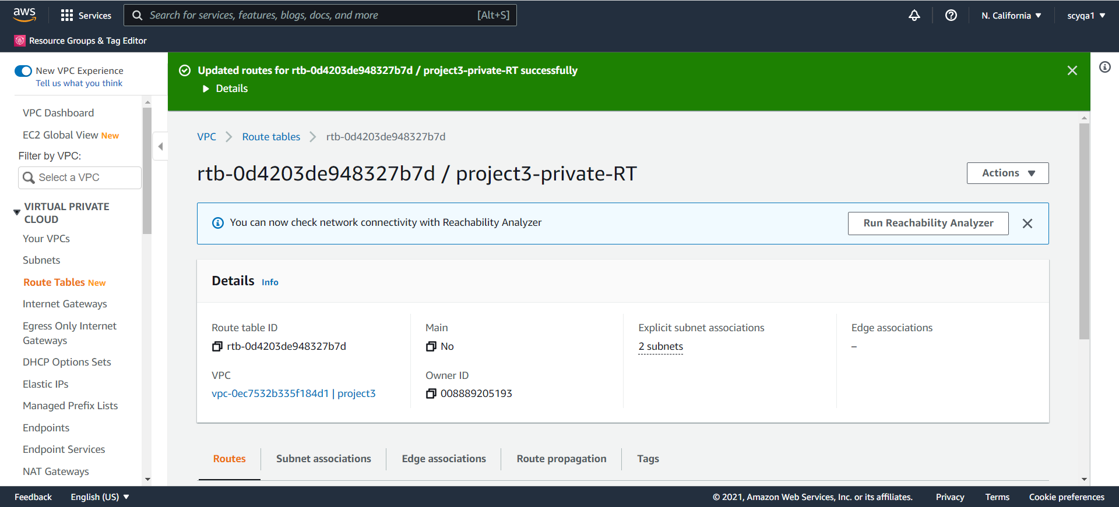

Create Elastic Load Balancer

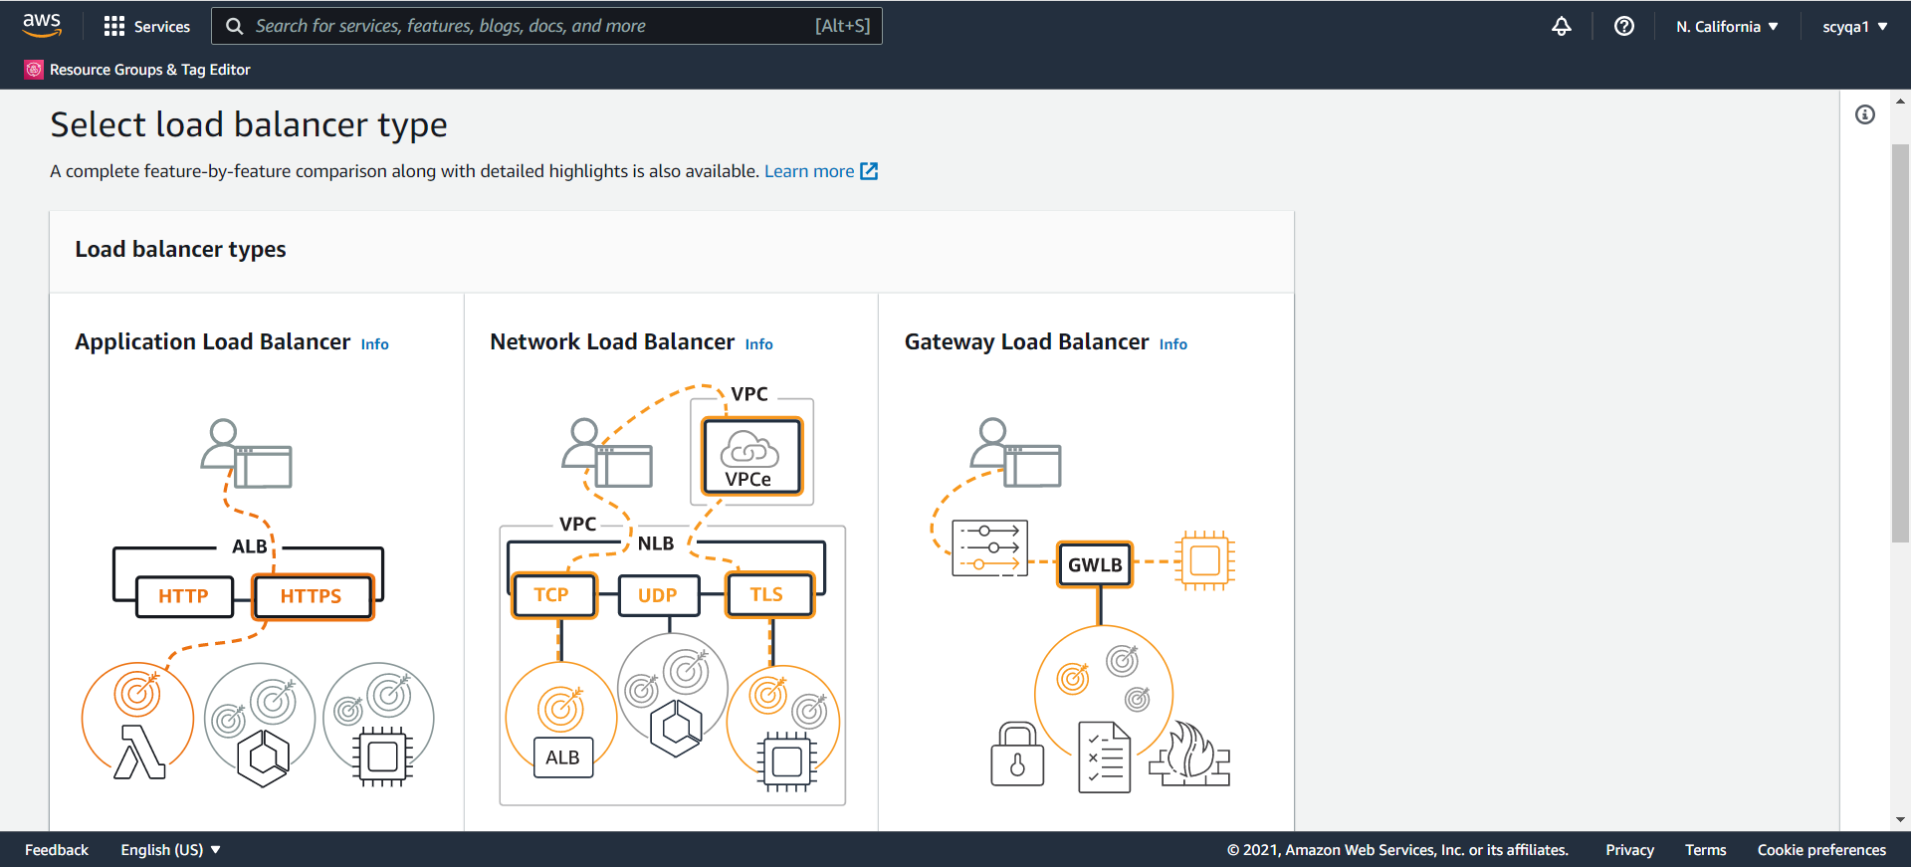

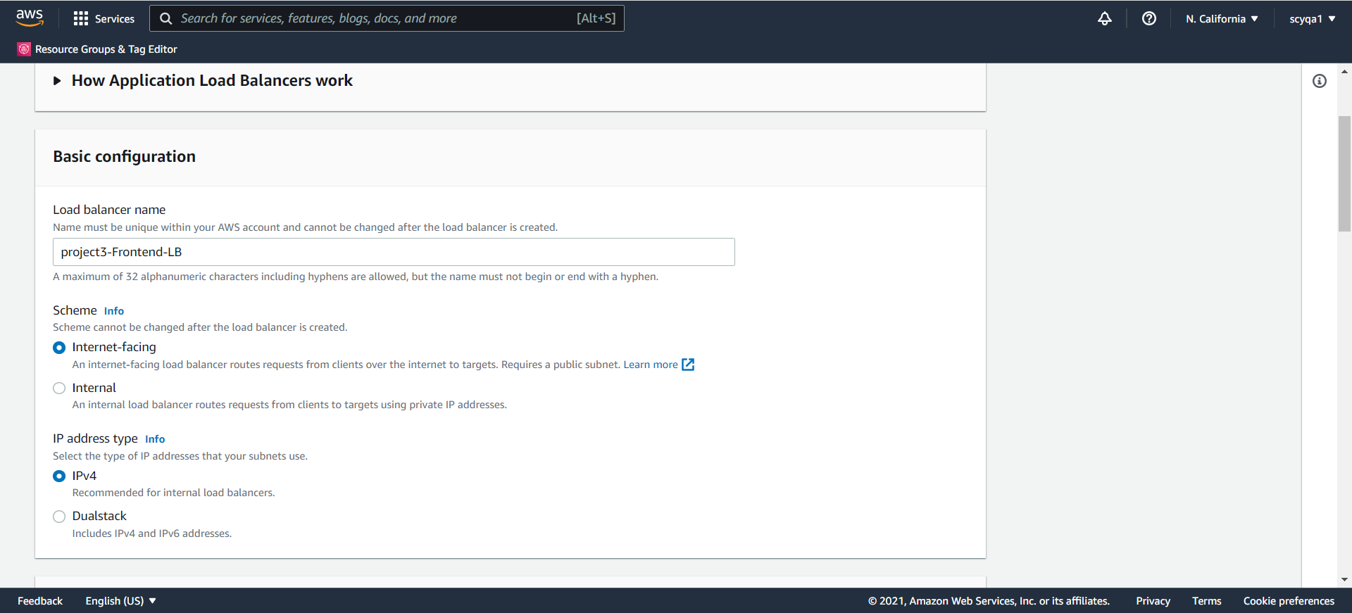

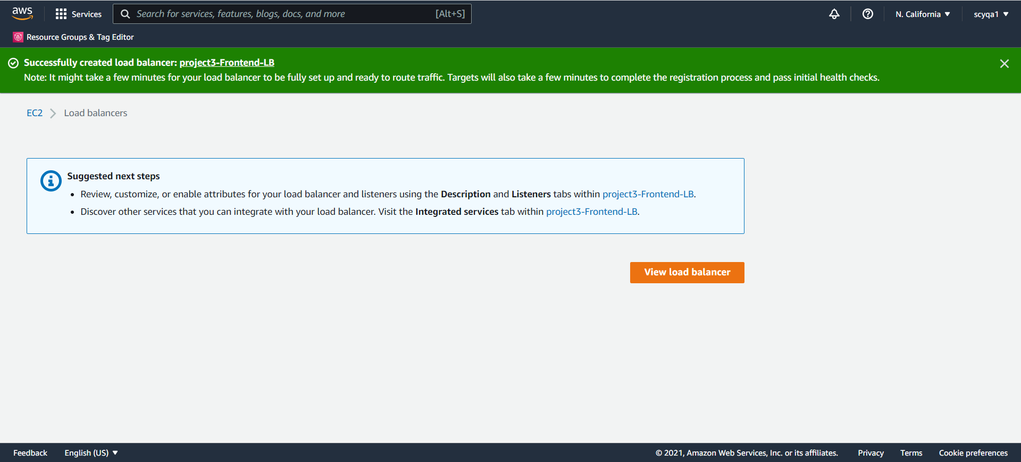

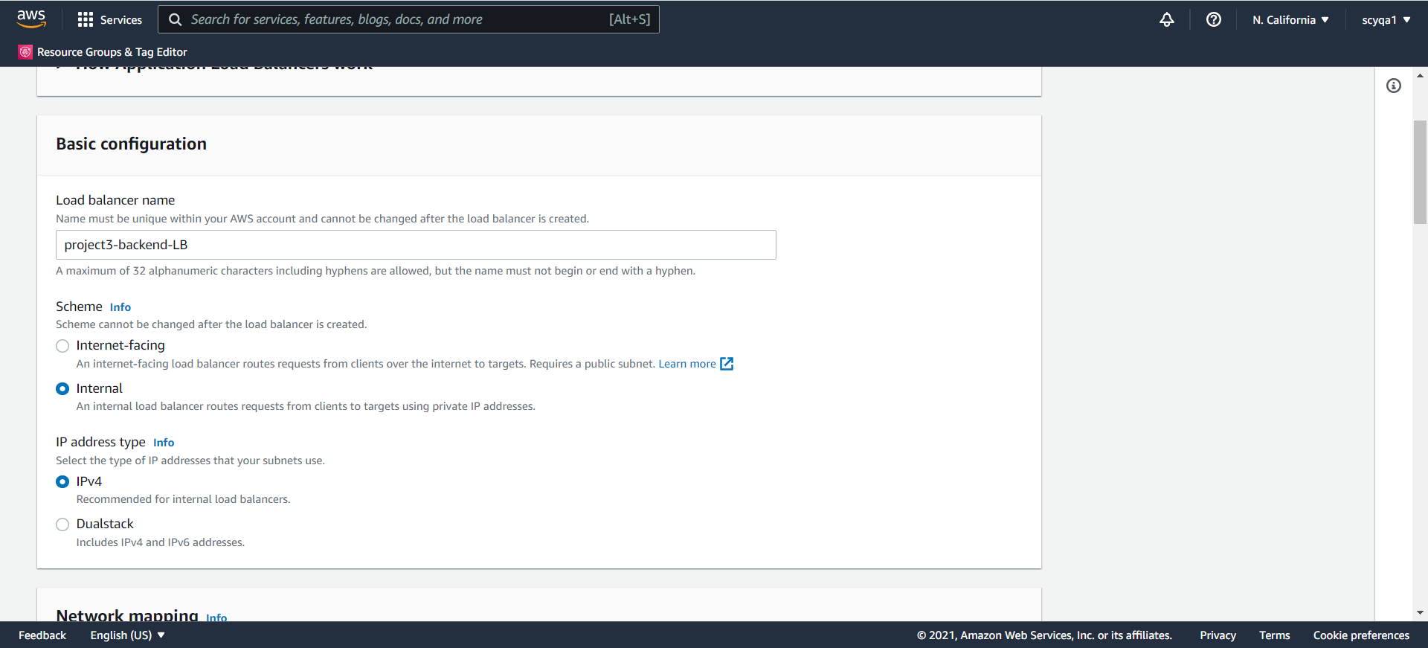

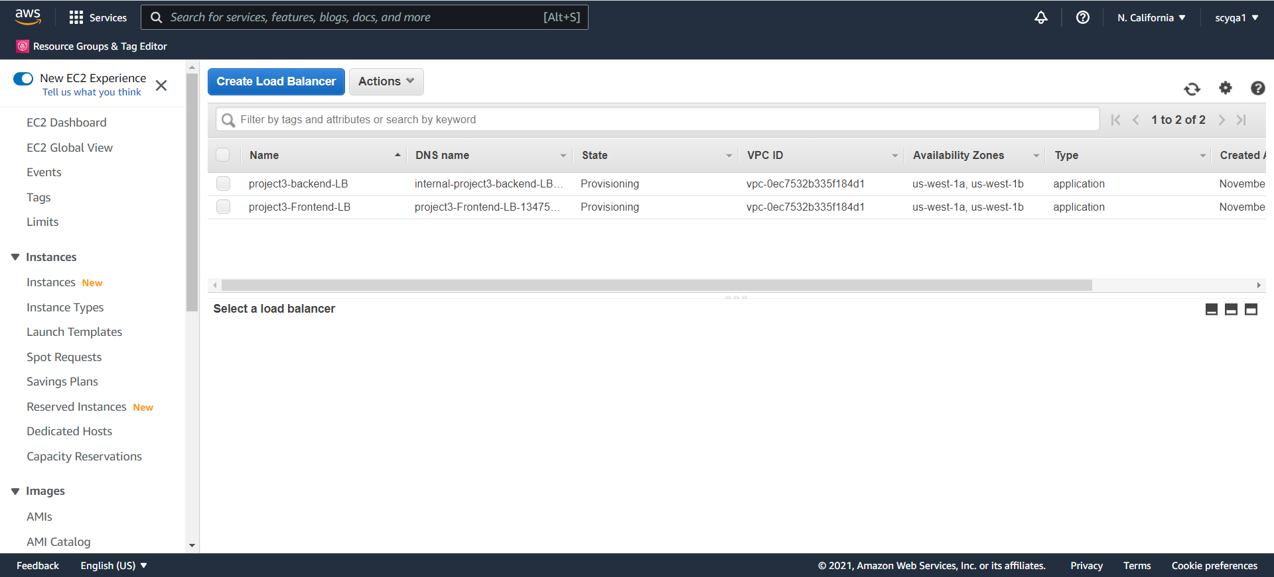

Bastion Host

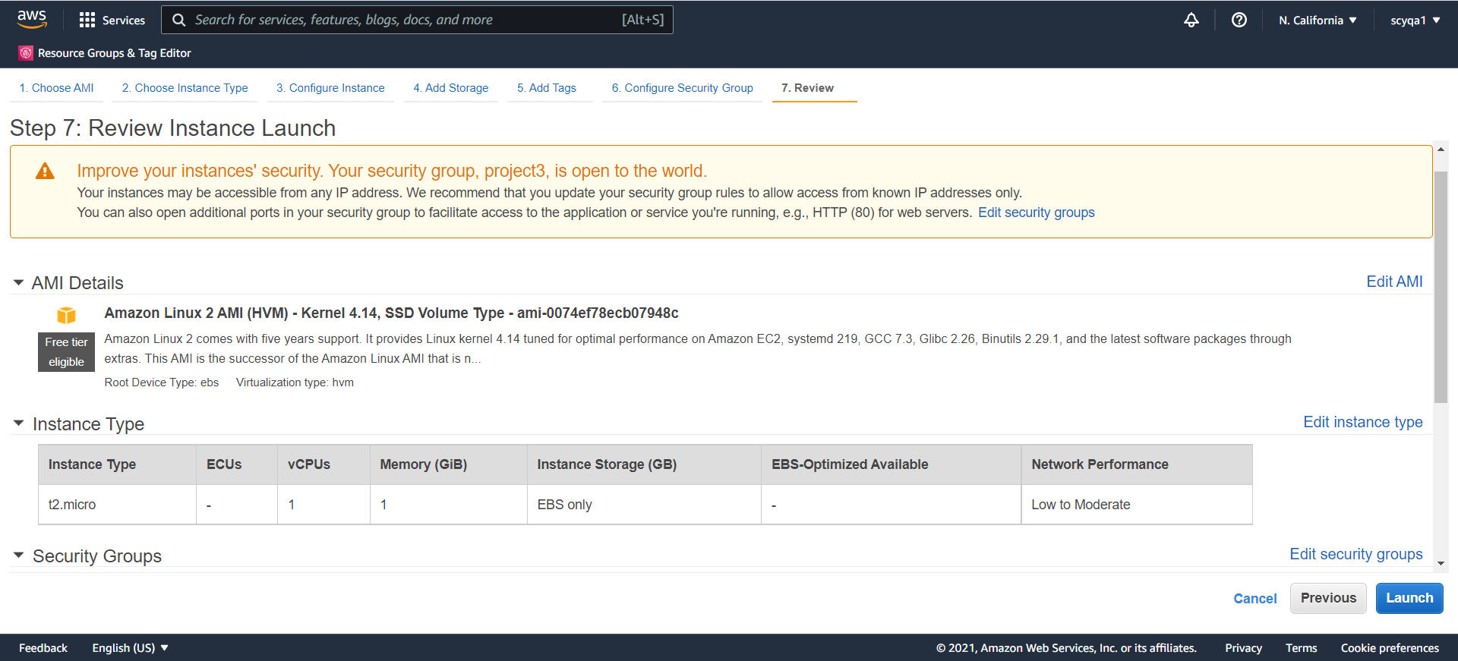

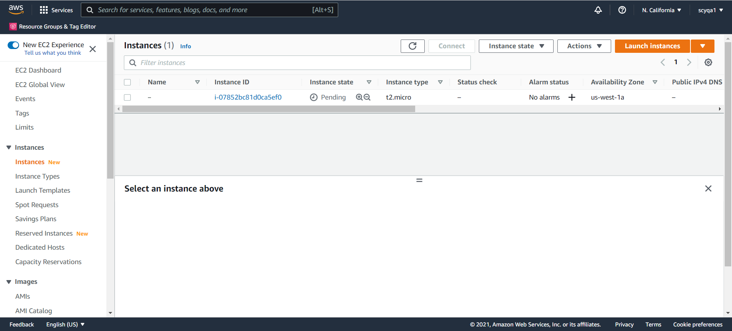

Step 2: deploy a Web App Then, deploy a basic Web app (SaaS) on this IaaS. The App can be the same as the Java eCommerce app you previously built, OR any other very simple web app you can adopt. Goal here is to deploy a basic web app on the IaaS you build in Step 1.

Before deployment, I would like to describe the design of the 3 tiers of the web application first.

For the Presentation tier, I would use Django as the eCommerce app I previously built.

For the App tier, I would use Zappa and AWS Lambda to deploy serverless Django web application. Also, I would use API calls to communicates with the data tier for this tier.

For the Data tier, I would use Amazon RDS.

For this SaaS web application, I encountered many difficulties - debugging is a great obstacle for me, even beyond my ability to address. There isn't any reference for this part. Finally, there are still some parts I can't deploy successfully.

Django eCommerce web app:

Before coding, create a virtual environment to manage dependencies.

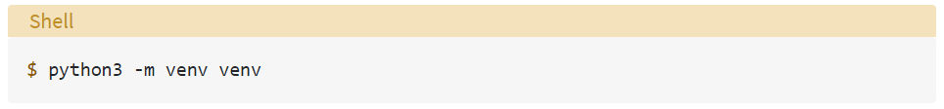

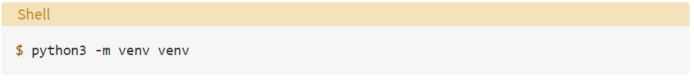

Then activate the virtual environment.

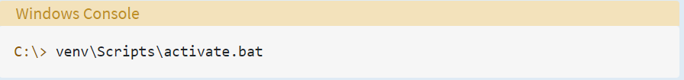

Install Django

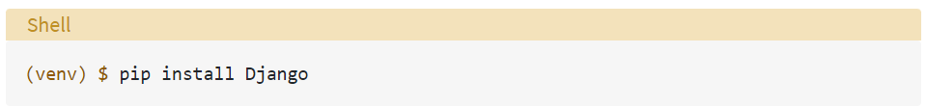

Then, create a Django Project with command below:

$ django-admin startproject ecommerce

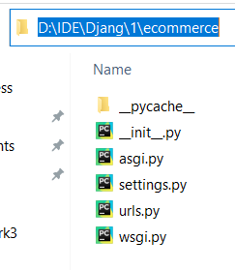

migrate admin database with command below:

$ python manage.py migrate

$ python manage.py makemigrations

Create a Django Application with command below:

$ python manage.py startapp

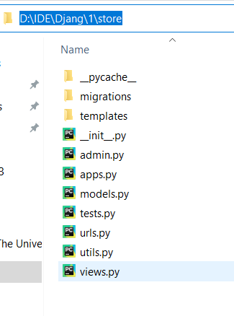

Running the development server with command below:

$ python manage.py runserver

manage.py

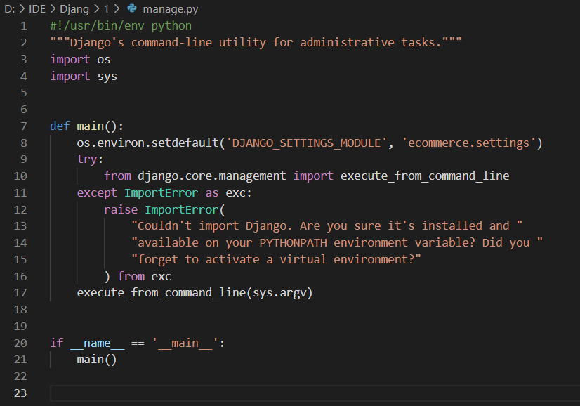

Templates

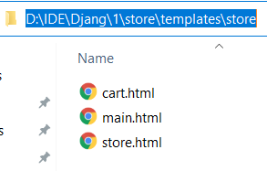

**Use Zappa and AWS Lambda to deploy serverless Django web application**

Activate the virtual environment

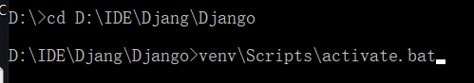

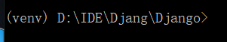

Install kappa (0.6.0)

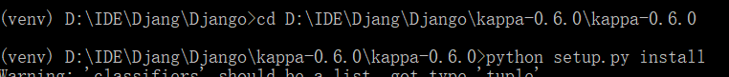

Install zappa (0.53.0)

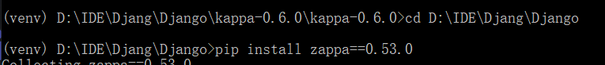

Zappa initialization

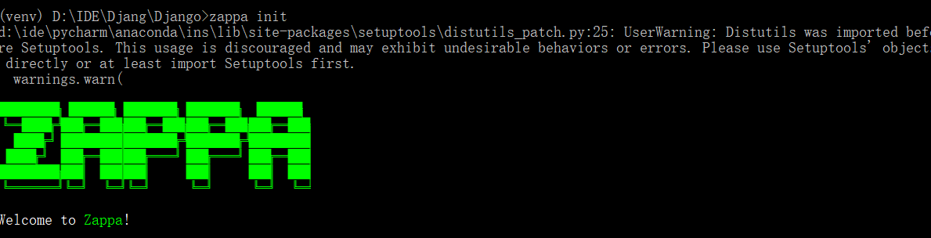

Zappa deployment



Then, configure the api gateway to the ‘settings.py’



Zappa update



Some other configurations

1. change add_description to set_description



2. zappa_settings.json

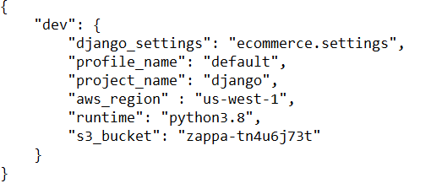

3. credentials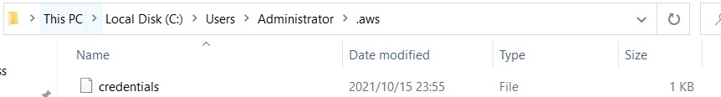

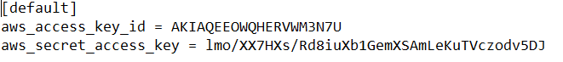

4. IAM

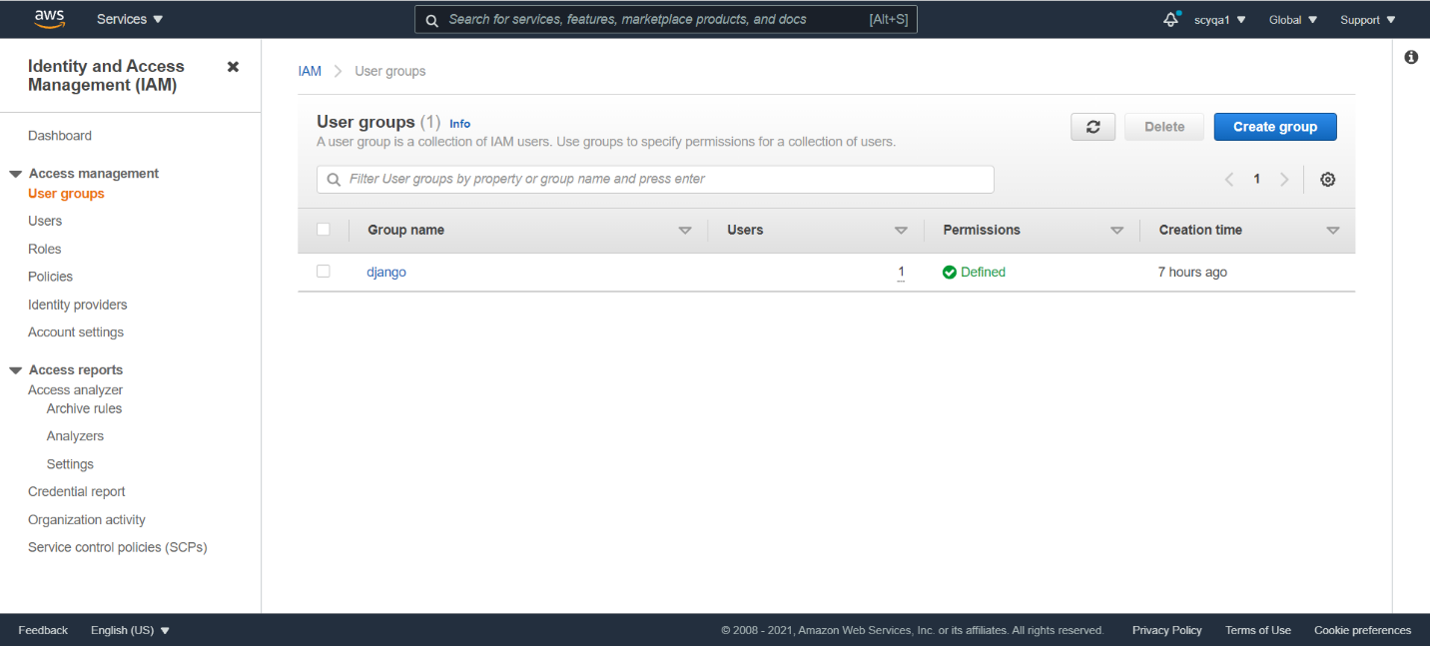

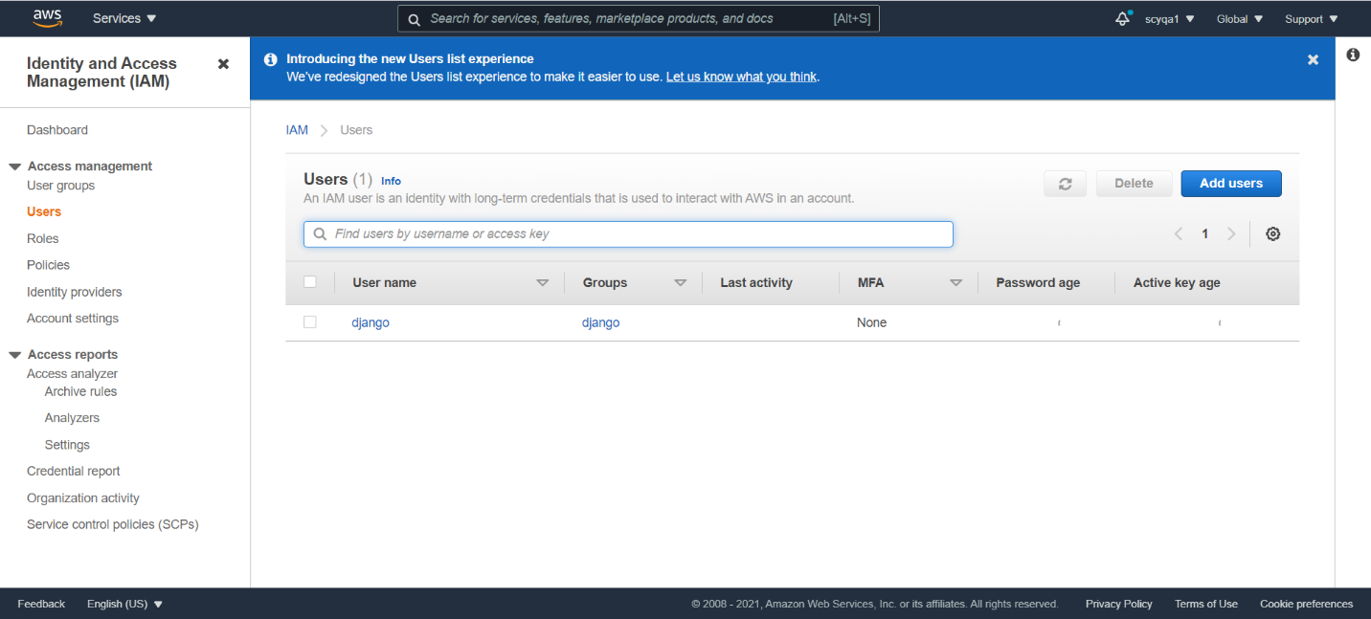

**Final Result:**

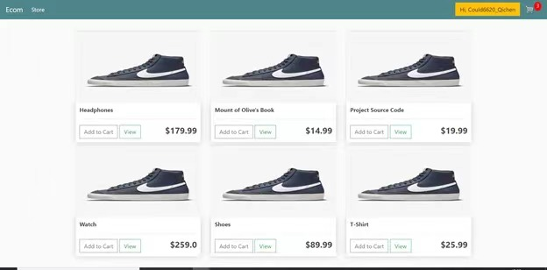

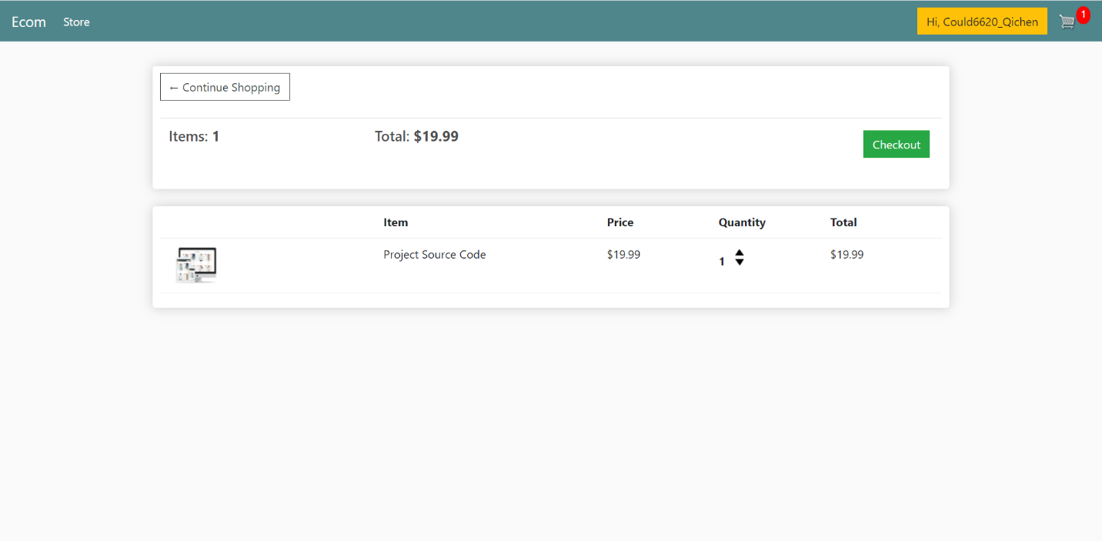

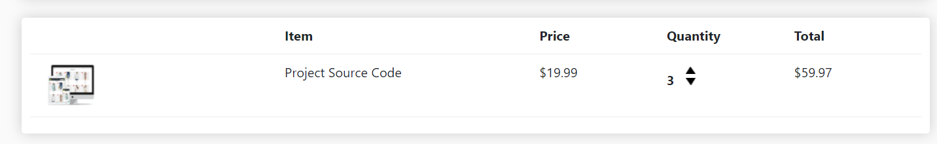

**Communicates with the data tier using API**

Settings:

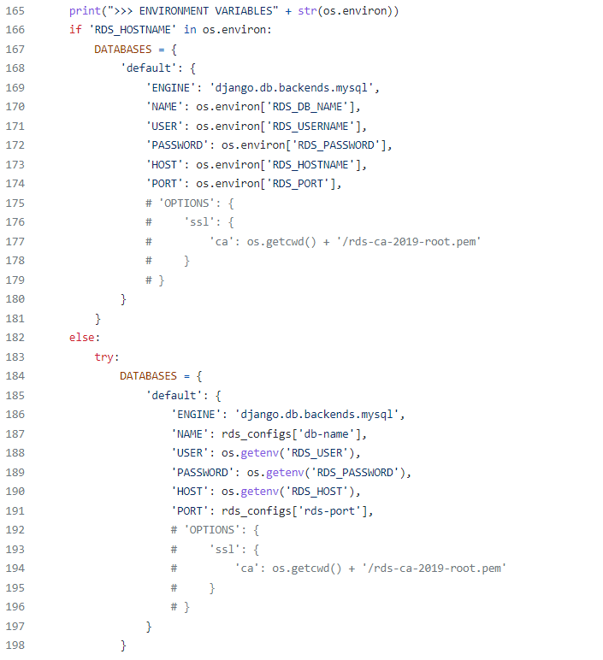

**Store data to RDS**

Example (Create a new user)

